<PROJECT NAME>

PREPARATION

Version <1.0>

<dd-mmm-yyyy>

This template helps outline the high-level project scope and begin getting preliminary governance, schedule, and compliance requirements outlined. It is intended to support the transition from a funded project proposal towards a Project Charter.

Version History

Overall, this toolkit is meant to support an Agile project management approach meaning that HIS projects are planned, designed and developed in an iterative manner in order to deliver based on the actual needs of the stakeholders and users of the product. This document is intended to be a guide of the topical areas you may need to plan the HIS project. Thus, you may not have all of the information at the start, so this document will be updated over time and the team should expect this template to have many versions and to grow over time. As major changes are made, please update the version number in the Title of document above, in the document’s headers, and complete the table below. This will support faster review from project stakeholders. Ensure the appropriate leadership signs off on major changes and new versions per project Governance plan.

|  |  |  |  |  |  |  |
| --- | --- | --- | --- | --- | --- | --- |
| **Version #** | **Main Author(s)** | **Revision**  **Date** | **Approved**  **By** | **Approval**  **Date** | **Major Change** | **Reason** |
| 1.0 | **<Author name>** | **<mm/dd/yy>** | **<name>** | **<mm/dd/yy>** | **<major change(s)>** | **<Reason)>** |
|  |  |  |  |  |  |  |
|  |  |  |  |  |  |  |
|  |  |  |  |  |  |  |

ABOUT THIS TOOLKIT

[The Health Information Systems Project Management toolkit was created for new and mid-level project managers to support preparation, planning, design, development, implementation, and project closeout processes. Overall, this toolkit is meant to support an Agile project management approach meaning that HIS projects are planned, designed and developed in an iterative way in order to deliver a product based on the actual needs of the stakeholders and end users of the product. This template serves as a guide and should be **tailored to your project and project needs.** Throughout the toolkit you’ll find useful links for additional templates, guidance (“boilerplate”) language to help guide, along with checklists to help project managers think through critical elements of this stage.



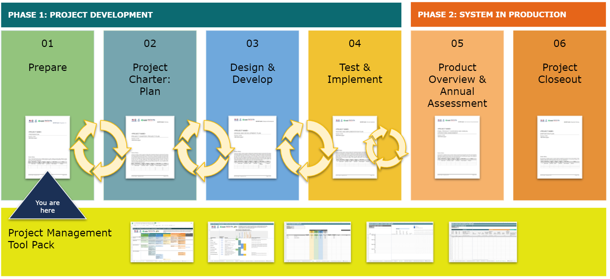

ACKNOWLEDGEMENTS

This toolkit was adapted from CDC’s Enterprise Performance LIfe Cycle Lite templates in early 2021. Thank you to all of the individuals and organizations who have contributed. Members of the HIS PM Toolkit workgroup, who advised and shared feedback on the Toolkit include: Briana Lozano (US Centers for Disease Control and Prevention), Jan MacGregor (TEKsystems), Herman Tolentino (US Centers for Disease Control and Prevention), Linda Taylor (Jembi Health Systems), Brianna Musselman (PATH), Carli Rogosin (Digital Initiatives Group at the International Training and Education Center for Health (DIGI/I-TECH), University of Washington) and Elizabeth Dunbar (Digital Initiatives Group at the International Training and Education Center for Health (DIGI/I-TECH), University of Washington). The HIS PM Toolkit workgroup was led by the Digital Initiatives Group at the International Training and Education Center for Health (DIGI/I-TECH), University of Washington, as part of the PATH Consortium.

FUNDER ACKNOWLEDGEMENT

The development of HIS products for global use is supported by the U.S. President’s Emergency Plan for AIDS Relief (PEPFAR) through the U.S. Centers for Disease Control (CDC) TAP central mechanism under the terms of a cooperative agreement. These products are solely the responsibility of the funding recipients and do not necessarily reflect the views of the United States Government.]

NOTE TO THE PROJECT MANAGER

[This document is a template of Project Prepare to help outline the business needs for this project. The template includes instructions to the author, boilerplate text, and fields that should be replaced with the values specific to the project. Feel free to simply add hyperlinks to other documents that satisfy requirements; there is no need to duplicate work.

* **<Text in Black with angle brackets to be completed by you and the project team>**
* Text in plain black is boilerplate language that can be modified or deleted. These are offered as guidance but not mandatory formats.
* [Text in fun purple is instructions for you or describes the intent. It should be deleted]
* [Text in purple with gray background are examples to guide team]

Here are the recommended steps for filling this template:

1. Replace all text enclosed in angle brackets (e.g., **<Project Name>**) with the correct information. These angle brackets appear in both the body of the document and in headers and footers.
   1. Add details by modifying the boilerplate text as appropriate to your specific project.
   2. Add new sections as needed:
      1. If you’re used to Microsoft Word you can use section headers Styles to label these additional sections so they will appear in the table of contents (e.g. Heading 1, Heading 2, Heading 3). A tutorial is available [here](https://support.microsoft.com/en-us/office/video-using-styles-in-word-9db4c0f4-2754-4294-9758-c14a0abd8cfa).
      2. To update the Table of Contents, right-click and select “Update field” and choose the option- “Update entire table”
      3. While these templates are in Microsoft Word, they can easily be added to Google Docs for collaboration.
2. Before submission of the first draft of this document,
   1. Delete this “Notes to the Project Manager” section and all instructions in purple text
   2. Consider additional sections that you would like to add. The Project Manager can determine which additions are most appropriate for this project.
3. During the project
   1. We expect this Preparation document to be updated. Please ensure that the Project Manager updates the Version in the document title along with the Version History table as modifications are approved. We suggest that the Project Manager also keeps a copy of all previous versions of the document.
   2. Please ask questions and share feedback about these templates by emailing [hispmtoolkit@gmail.com](mailto:hispmtoolkit@gmail.com)

**Useful Links and Templates**

|  |  |  |
| --- | --- | --- |
| What | Purpose | Where |
| Budget Template | Part 1 of budget template can help estimate cost | [PM Tool Pack](https://docs.google.com/spreadsheets/d/1x6bdkl0v0tiS_a5sTzBaxFIXVUVtvZMw/edit#gid=862329129) |
| Gantt Chart | Outline of project steps and timeline | [PM Tool Pack](https://docs.google.com/spreadsheets/d/1x6bdkl0v0tiS_a5sTzBaxFIXVUVtvZMw/edit#gid=862329129) |
| Site Preparedness Checklist | Facility-based assessment to determine features and readiness for health informatics project | [PM Tool Pack](https://docs.google.com/spreadsheets/d/1x6bdkl0v0tiS_a5sTzBaxFIXVUVtvZMw/edit#gid=862329129) |
| Additional Tools |  |  |
| Info Savvy Self Assessment | This assessment can help your team where your organization falls on informatics savviness continuum.It will help you systematically review vision and strategy, workforce, and design of information systems. | [Link](https://www.phii.org/resources/view/9612/informatics-savvy-health-department-self-assessment-tool) |
| Information Governance for Public Health | This document outlines some principles for good governance structures for information management | [Link](https://phii.org/node/9615) |
| PHII Requirements for Public Health Preparedness Information Systems | Defining requirements is a critical step in developing or acquiring an information system. The Common Ground Project was designed to assist chronic disease and preparedness US-based departments in public health agencies to document and define business processes common to each of them, and to identify the requirements for information systems to effectively support these processes. This document summarizes the work of and presents the requirements developed by the Common Ground Preparedness Workgroup. | [Link](https://phii.org/resources/view/154/requirements-public-health-preparedness-information-systems) |

**Project Preparation Checklist**

* The executive summary demonstrates a clear alignment between the project and overall organisational strategy in plain language (no jargon).
* The project scope is clearly stated: the reader can easily understand what product, service, or result will be delivered by the project and what high-level activities will be performed.
* Consider conducting Site Preparedness Checklist to inform the project plan ([PM Tool Pack](https://docs.google.com/spreadsheets/d/1x6bdkl0v0tiS_a5sTzBaxFIXVUVtvZMw/edit#gid=862329129))
* If project is a well-known solution (e.g. OpenMRS, OpenELIS, with good documentation that’s available publicly, labeled as a “[global good](https://digitalsquare.org/global-goods-guidebook)”, has strong community of practice), ensure the project is appropriately scoped to your context that includes a phased rollout plan per available use cases, evidence, and/or publications
* If project is a proof-of-concept or a new innovation, describe how this project may be innovative in solving the problem and integrates into existing Health Information Systems landscape
* Provide summary cost estimates and source of funding to produce internal and external deliverables, including the project management and administrative effort as well as any equipment required (hardware, software, floor space, etc.).
* Ensure the project aligns with overall enterprise architecture
* Ensure local and international legislation, [standards or guidelines](https://www.youtube.com/watch?v=KSEUh-wj7Y0) are identified and begin mapping out compliance strategies
* Identify the stakeholders of this technology, considering both direct (those who will routinely and directly interact with the technology) and indirect (those who are affected by the technology, e.g. may receive data from the system)
* Define a governance process to approve this initial project scope and plan, to support solving issues when required, to approve changes to the project (scope, artifacts, budget, schedule), and to review deliverables.
* Create and get project approval: who internally to your organization needs to sign off on this plan? Who externally needs to sign off? Ensure the correct persons are identified in Appendix A. This process may also be articulated in the project Governance section.
* Consider presenting analysis of Alternative solutions using Appendix B to support selection of product or infrastructure for this project, and ensure this justifies product, service or result selected

**TABLE OF CONTENTS**

**EXECUTIVE SUMMARY** **7**

**PROJECT DESCRIPTION:** **8**

GOALS AND OVERVIEW 8

PROJECT INFORMATION 8

FINANCIAL CONSIDERATIONS 8

**PROJECT ORGANIZATION** **8**

GOVERNANCE 8

PROJECT COMMUNICATION PLAN 10

PRELIMINARY ACQUISITION PLAN 10

PRELIMINARY PROJECT SCHEDULE AND WORK BREAKDOWN 10

PROJECT SCHEDULE MANAGEMENT 10

**COMPLIANCE REQUIREMENT PLANNING** **10**

**APPENDIX A: PROJECT PREPARATION APPROVAL** **11**

**APPENDIX B: ALTERNATIVES AND ANALYSIS** **12**

ALTERNATIVE A 12

ALTERNATIVE B 12

# EXECUTIVE SUMMARY

[Provide a synopsis of the key points of the overall project purpose and the business case. A Business Case assists stakeholders in deciding effort and scope of a proposed project effort. It is the main guide linking the project ***proposal*** to the project ***plan***, and can be used to explain the project to key stakeholders **before** major planning begins. It also serves to outline both the project governance and how the project will adhere to specific laws and regulations. Make a simple outline for why this investment and project, how it aligns with goals of organization/project implementers. Make this summary for a lay person, meaning someone who is unfamiliar with this project and does not understand acronyms or technical jargon.]

## 

# 

# 

# PROJECT DESCRIPTION:

## GOALS AND OVERVIEW

[Provide a brief description of the project goals. This can typically be pasted from the project proposal. Also briefly state the business need for the project, its public health/business impact, and how the project goals align with the goals of project stakeholders, including Ministry of Health, CDC, and other core stakeholders]

## PROJECT INFORMATION

|  |  |
| --- | --- |
| **Project Name** | <Provide Name of Investment/Project> |
| **Name of Sponsor Organization** | <Provide Business Sponsor’s organization> |

## FINANCIAL CONSIDERATIONS

[Identify potential and existing funding sources for all project component costs for the preferred solution. This should include consideration of items such as capital costs, operating costs, total cost of ownership, impact on other projects, funding requirements, etc. Use the Part 1 of the Budget template to estimate costs that can be filled into the section below.]

|  |  |  |  |
| --- | --- | --- | --- |
| **Funder** | **Component** | **Cost** | **Amount Funded** |
|  |  |  |  |
|  |  |  |  |
|  |  |  |  |

# 

# PROJECT ORGANIZATION

## GOVERNANCE

Overall, this HIS project will be governed by the following processes:

[Add specific language for how this project will be overseen.

* How will this project be governed? Consider creating a decision workflow (see example below). List any specific roles and responsibilities who will be part of governance process
* Have you considered specific timelines or deadlines within which decision should be made?
* Will the project be part of an existing Technical Working Group (TWG) or sub-TWG?
* Will the project be specifically managed by a consortium of partners or executive committee?
* Who will be essential in reviewing and approving documentation for this project?
* What happens when a key decision maker is not available? Are there specific person(s) who can be delegated sign-off responsibilities?
* How might decision workflows be different when project changes require additional budget?
* What are the core meetings required? What other communications may be required?
* How will end users (business stakeholders, implementing partners) be part of the governance process?
* Who are the direct stakeholders of this project (e.g. those who will be directly using the technology) and how will they be involved in governance?
* Who are the indirect stakeholders of this project (e.g. those who may be affected by or benefit from technology or data, but not directly use the technology) and how will they be involved in the governance process?
* How will this project connect with other communities like OpenHIE, Open Concept Lab, OpenMRS etc.?

**Project RACI Table**

The following Responsible, Accountable, Consulted, and Informed (RACI) table describes how this project will be governed, including specific activities or documents and how stakeholders will be involved in production, review, and approval.

**­­**

|  |  |  |  |  |
| --- | --- | --- | --- | --- |
| Project Governance Activity or Document | **RESPONSIBLE**  **performs work** | **ACCOUNTABLE**  **checks in can veto / approve** | **CONSULTED**  **asked for input** | **INFORMED**  **decision or output shared** |
| Project changes that may have a budget impact (amount threshold or days) | Project Manager | Funder | Ministry of Health | All parties |
| Major changes to the Prepare document |  |  |  |  |
|  |  |  |  |  |

**Project Decision Workflow**

The following workflow outlines how project decisions will be made.

Diagram was made using Draw.io software ([template](https://app.diagrams.net/#G19c18yzkg04LjZWmT3wWaHov1MmKMaYcI))

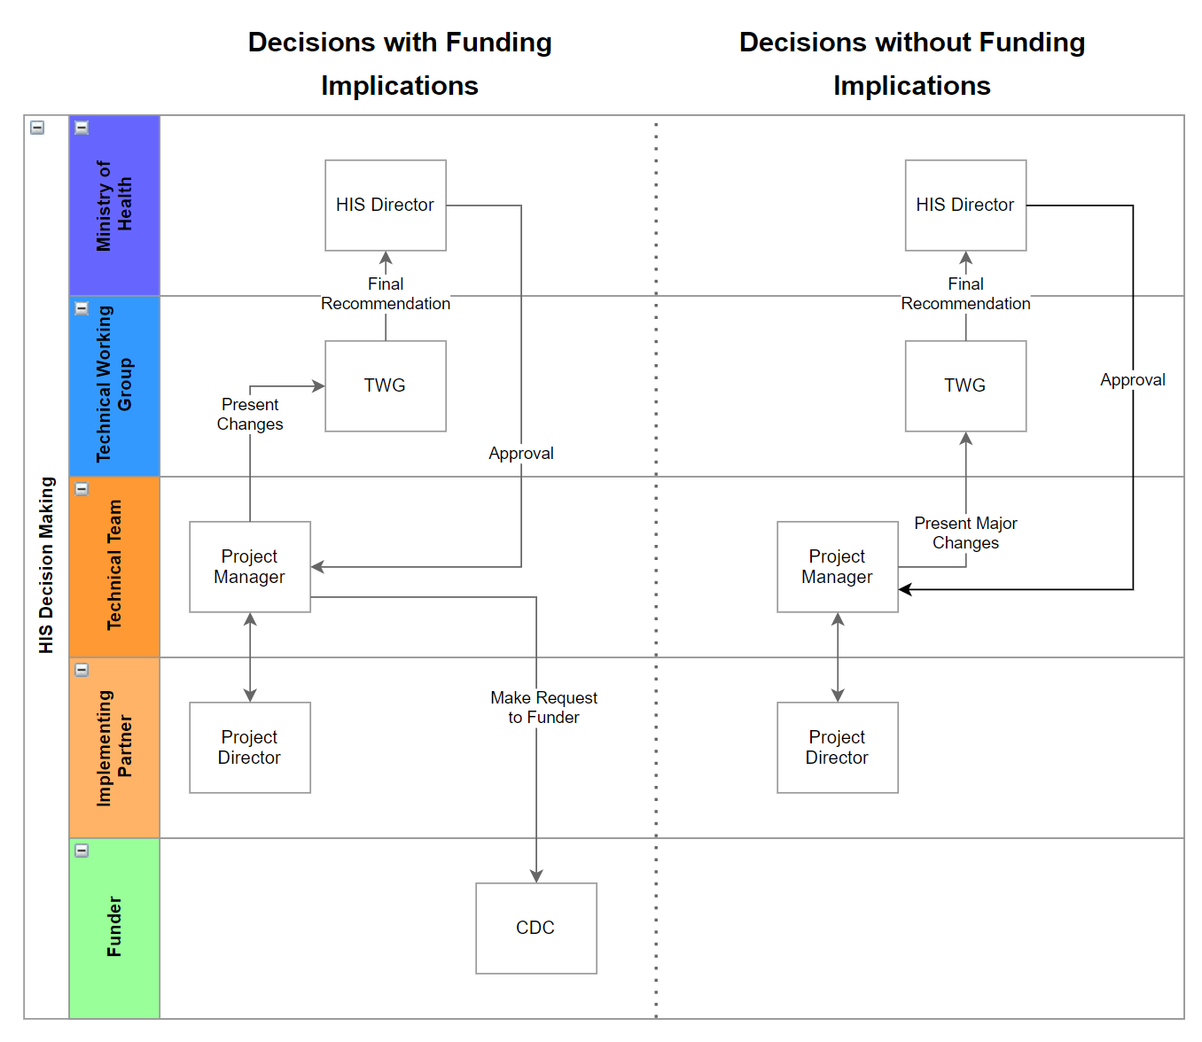

## PROJECT COMMUNICATION PLAN

The following table outlines what meetings and/or communications materials are required for this project.

|  |  |  |  |  |
| --- | --- | --- | --- | --- |
| What | Purpose | Frequency (When) | Who | How Will Meet |
|  |  |  |  |  |
|  |  |  |  |  |

## PRELIMINARY ACQUISITION PLAN

[Identify acquisition sources for the preferred solution that includes all project supplies (hardware, software), services (development), and commercial items. Can items be procured locally? Will they require importing?]

## PRELIMINARY PROJECT SCHEDULE AND WORK BREAKDOWN

A project schedule is the agreed upon set of activities, tasks and due dates used to guide and monitor the project to completion. There are many formats and software that can support project schedule development. Basic project schedules should contain tasks, due dates, who is responsible, and overall timelines. In this section, capture a draft project schedule: it should include a bullet list of project milestones, timelines, deadlines and who will be completing each task. You could use a draft Gantt Chart]

## **PROJECT SCHEDULE MANAGEMENT**

[At this stage, outline who is responsible for managing the project schedule, if known]

|  |  |
| --- | --- |
| Name of Schedule Manager |  |
| Schedule Manager Contact Information | Email:  Phone:  Whatsapp: |
| How frequently will the schedule be revised? |  |
| Who needs to be informed if the schedule changes?  [Be specific if there are particular stakeholders or specific situations. Any unacceptable increase in schedule should be reviewed according to the project’s Change Control processes.] |  |

# COMPLIANCE REQUIREMENT PLANNING

[Describe the existing policies or laws that are required for this project. Include an overview of the compliance requirements necessary to achieve the project’s objectives. Describe how the project will comply with these regulatory requirements. This is a good place to list any policies or requirements from MOH or international standards (OpenHIE, Open Concept Lab, OpenMRS Concept Dictionary etc). You will build a more complete list in the planning stage but this section should help the project team to identify how this project and its components fit into any existing Enterprise Architecture or outline major Enterprise Architecture and areas for compliance.]

# APPENDIX A: PROJECT PREPARATION APPROVAL

The undersigned acknowledge they have reviewed the ***<Project Name>*** Preparation Plan and agree with the approach it presents. Changes to this Preparation Plan will be coordinated with and approved by the undersigned or their designated representatives.

[List the individuals whose signatures are desired. Examples of such individuals are Project Manager, Government officials, Implementing Partners, or Project Sponsor. Add additional lines for signature as necessary. Although signatures are desired, they are not always required to move forward with the practices outlined within this document.]

|  |  |  |  |
| --- | --- | --- | --- |
| Signature: |  | Date: |  |
| Print Name: |  |  |  |
| Title: |  |  |  |
| Role: |  |  |  |

|  |  |  |  |
| --- | --- | --- | --- |
| Signature: |  | Date: |  |
| Print Name: |  |  |  |
| Title: |  |  |  |
| Role: |  |  |  |

|  |  |  |  |
| --- | --- | --- | --- |
| Signature: |  | Date: |  |
| Print Name: |  |  |  |
| Title: |  |  |  |
| Role: |  |  |  |

# 

# 

# APPENDIX B: ALTERNATIVES AND ANALYSIS

[If relevant, the Alternative Analysis section should identify options and alternatives to the proposed project and the strategy used to identify and define them. Further analysis of these potential options should be performed to identify a preferred solution. Include a description of the approaches for the identification of alternatives and an outline/description of each alternative considered. Some examples of alternatives to consider may include:

* Buy vs. build vs. lease vs. reuse of existing system
* Outsource vs. in-house development
* Commercial off the shelf (COTS) vs. Government off the shelf (GOTS)
* Mainframe vs. server-based vs. clustering
* Unix vs. Linux vs. Windows]

### ALTERNATIVE A

One approach to presenting the alternatives analysis is illustrated in the section below. The content of such a section may vary between projects based on the type of alternatives being analyzed and the approach taken. Include a detailed alternative analysis that contains information such as:

* Cost/benefit analysis
* Initial and ongoing costs
* Payback period
* Return on investment (ROI)
* Other financial consideration
* Security considerations
* Etc]

|  |  |  |  |  |  |  |
| --- | --- | --- | --- | --- | --- | --- |
| **Alternatives Analysis** | **Year1** | **Year2** | **Year3** | **Year4** | **Year5** | **Total** |
| ***Alternative A***  *Cost of Alternative*  *Cost Savings*  *Cost Avoidance*  *Stakeholder Benefit*  ***Total Benefit*** | *($550,000)*  *$0*  *$200,000*  *$50,000*  ***($300,000)*** | *($50,000)*  *$0*  *$0*  *$10,000*  ***($40,000)*** | *($150,000)*  *$0*  *$200,000*  *$50,000*  ***$100,000*** | *($150,000)*  *$0*  *$200,000*  *$50,000*  ***$100,000*** | *($150,000)*  *$0*  *$200,000*  *$50,000*  ***$100,000*** | *($750,000)*  *$0*  *$1,000,000*  *$250,000*  ***($40,000)*** |

### ALTERNATIVE B

[Include a detailed alternative analysis that contains information such as that outlined in Alternative A, continue with as many alternatives as available]