Point-of-care diagnostics to guide malaria care

New tests for glucose-6-phosphate dehydrogenase (G6PD) deficiency to support *Plasmodium vivax* elimination efforts

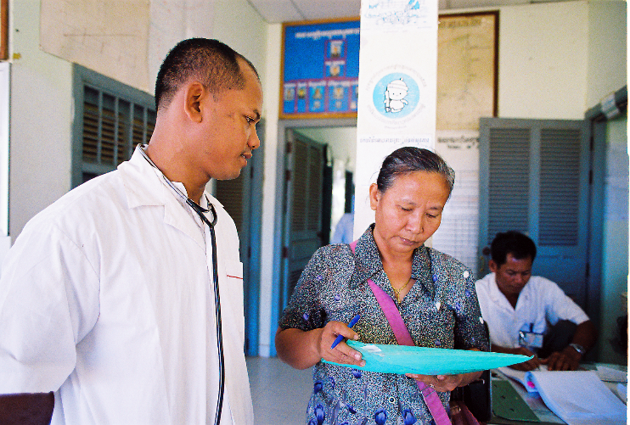**Background**

Malaria is an infectious disease caused by the *Plasmodium* parasite that causes disease for millions of people worldwide each year. Malaria is targeted for global elimination—that is, the reduction of transmission until new cases are no longer occurring.

Up to 2.85 billion people may be at risk of infection with *Plasmodium (P.) vivax*,a form of malaria found in Asia, Latin America, and East Africa. *P. vivax* is the most difficult type of malaria to fully treat because a form of the parasite known as the hypnozoite can lie dormant in the liver and cause illness weeks or months after the first infection. *P.vivax* is also hard to eliminate because during these relapses the patient also becomes infective, perpetuating the cycle of infection with *P. vivax* in the community.

A common hereditary condition known as G6PD deficiency poses a threat to efforts to eliminate malaria. Testing individuals for the condition is essential for patient safety and to accelerate elimination efforts. PATH/H. Chivoan

All hypnozoites in the body must be killed to completely cure a patient with *P. vivax* and stop the spread of disease. This is known as “radical cure.” Currently, radical cure for *P. vivax* can be achieved only through treatment with primaquine, an 8-aminoquinoline–based drug. However, patients deficient in glucose-6-phosphate dehydrogenase (G6PD), an enzyme that helps protect red blood cells from oxidative damage, are at risk of hemolytic anemia when treated with 8-aminoquinolines such as primaquine.

Challenges to g6pd testing

Because of the risk of hemolytic anemia, patients with severe G6PD deficiency should not receive the standard course of 8-aminoquinolines for radical cure of *P. vivax*. Furthermore, because females can carry the gene that causes G6PD deficiency on one or both X chromosomes (known as heterozygosity), these females can have varying levels of G6PD activity, which may put them at risk of adverse reactions to 8-aminoquinolines.

It is estimated that 400 million people worldwide are G6PD-deficient, and the condition is common in areas where malaria is endemic. However, simple and rapid tests for G6PD deficiency are not widely available at the point of care (POC), and the tests that are available are not able to detect heterozygous females with intermediate G6PD activity who may be at risk of hemolytic anemia. This poses a major challenge to *P. vivax* elimination efforts. A POC diagnostic for G6PD deficiency is needed to enable wide-scale treatment of patients with *P. vivax* malaria and accelerate elimination of the disease.

Laying the foundation

PATH and our partners are advancing new diagnostic tests for G6PD deficiency that may help guide appropriate clinical care of patients and support *P. vivax* elimination efforts.

PATH performed comprehensive analyses of the G6PD diagnostic landscape, conducted prospective comparative studies of G6PD assays, and applied the data to develop target product profiles for tests to support malaria case management. In addition, PATH developed GeoDx, an interactive tool to model demand and cost estimates for various G6PD tests in different geographic and epidemiological settings.

PATH also developed a unique specimen repository containing samples of blood with a range G6PD activity, including deficient and intermediate samples; the repository allows PATH and its partners to draw upon reliable sources of G6PD-deficient samples to use in the development and evaluation of new diagnostic tests. The specimen repository is available to all manufacturers developing G6PD diagnostic tests to support malaria treatment.

New POC G6PD tests

PATH is undertaking several product development partnerships with the aim of ensuring the availability of G6PD testing options that best meet the needs of healthcare providers managing malaria cases.

We are collaborating with GSK to advance tests that could support use of tafenoquine. Tafenoquine is an investigational 8-aminoquinoline–based drug being developed by GSK and Medicines for Malaria Venture that targets *P. vivax* hypnozoites in a single treatment.

PATH has taken a portfolio approach, working with multiple diagnostic test developers to develop and evaluate G6PD diagnostic tests. The products include tests that measure G6PD activity and hemoglobin in whole blood and as well as qualitative tests that can safely exclude patients with severe G6PD deficiency. These G6PD diagnostic tests are expected to become available between 2018 and 2019. In addition, PATH has been working with global and in-country partners to increase access to the new POC G6PD diagnostic tests.



G6PD deficiency is common in areas where P. vivax malaria is close to elimination. PATH/Molly Mort

about path’s malaria work

PATH works in partnership with national governments, the private sector, and global stakeholders to make a malaria-free world a reality. PATH pursues this goal by expanding the use of lifesaving tools and developing new strategies to create malaria-free communities; working to ensure a steady, affordable, and high-quality supply of drugs and diagnostics; and bringing together public- and private-sector partners to advance the development of malaria vaccines and diagnostics.

contact

To learn more about G6PD diagnostics, visit <http://sites.path.org/dx/malaria/g6pd/>or contact Gonzalo Domingo, scientific director and lead of malaria diagnostics at PATH, at [dxinfo@path.org](mailto:dxinfo@path.org).

This project is supported by grants from the UK Department for International Development and the Bill & Melinda Gates Foundation.