**Intergovernmental Learning Exchange to Advance Data-Driven Decision-Making (I-LEAD)**

Facilitators’ Guide

September 2025

Contents

Contents 1

List of abbreviations and acronyms 2

List of tables 3

List of diagrams 4

Section 1: Introduction 5

Purpose and learning outcomes 6

What is I-LEAD, and why was it designed this way? 6

What is I-LEAD? 6

I-LEAD facilitation approach 6

What is this guide, and who is it for? 6

Purpose 6

Focus 7

Target audience 7

Section 2: Foundations of effective adult learning 7

Purpose 8

Understanding learning progressions 8

Bloom’s Taxonomy and learning progression in training design 8

Assessment alignment 10

Habit formation: Linking learning to sustainable behavioral change 10

Adult learning principles 12

The six principles and their application in I-LEAD 12

Section 3: Types of learners and learning modalities 13

Purpose 14

Visual, auditory, reading/writing, and kinesthetic (VARK) 14

Types of learners 15

Learning styles in in-person, live virtual, and self-paced virtual contexts. 15

Section 4: Designing a training session 17

Purpose 18

The training cycle 18

Targeting and structuring content 18

Bulls-eye model (Must Know/Should Know/Could Know) 19

Adjusting technical content for diverse audiences 20

Session planning 21

Selecting methods: presentations, discussions, simulations, and case studies 21

Planning for engagement: pacing, transitions, and timing 23

Section 5: Facilitating learning 26

Purpose 27

Core facilitation skills 27

Facilitation skills 27

Body language, voice modulation, handling difficult questions, and inclusivity 27

Body language 27

Voice modulation 28

Handling difficult questions 29

Making sessions interactive 31

Icebreakers vs. learning activities 31

Microteaching 35

Gamification strategies 37

Managing audiences 39

Time breakdown for content, discussion, and review 39

In-person: Room setup, breakout rooms, and group dynamics 40

Section 6: Monitoring learning 41

Purpose 42

Assessment versus evaluation 42

Definitions and differences 42

Pre-training and post-training tests, surveys, and real-time feedback tools 42

Pre-training and post-training tests 42

Survey 43

Real-time feedback tools 43

Digital tools: Kahoot!, Mentimeter, Slido, Google Forms, Jeopardy Games 45

Reinforcement strategies 47

Using quizzes, action planning, and recap activities to reinforce learning 48

Section 7: Post-training support 53

Purpose 54

Coaching 54

Role of coaching and feedback in skill building 54

Communities of practice 57

Rationale, structure, and examples 57

Section 8: Special considerations 60

Selecting and managing facilitators 61

Digital tools directory (Miro, Mural, Padlet, and Microsoft Whiteboard) 61

References 64

List of abbreviations and acronyms

CDC Centers for Disease Control and Prevention

CLEAR Contract, Listen, Explore, Action, Review

CoP community of practice

CRM Customer Relationship Management

GROW Goal, Reality, Options, Will

HRIS Human Resource Information System

I-LEAD Intergovernmental Learning Exchange to Advance Data-Driven Decision-Making

LMS Learning Management System

OSKAR Outcome, Scaling, Know-How, Affirm & Action, Review

TGROW Topic, Goal, Reality, Options, Will

VARK Visual, Auditory, Reading/Writing, Kinesthetic

List of tables

Table 1. Levels of the cognitive process dimension of Bloom's Taxonomy 5

Table 2. Types of knowledge in Bloom's Taxonomy 5

Table 3. Stages of the habit-forming process 7

Table 4. Learning styles in the VARK model 10

Table 5. Key differences in learning styles: In-person vs. live virtual vs. self-paced virtual training 13

Table 6. Summary of Must Know, Should Know, and Could Know content categories 16

Table 7. Key audience questions for adjusting technical content 17

Table 8. Tailoring content to different audiences 17

Table 9. Techniques for tailoring training content 18

Table 10. Qualifying criteria for selecting training delivery methods 18

Table 11. Example of applying selection criteria—the Marshmallow Challenge 20

Table 12. Example of a facilitator's training agenda template 23

Table 13. Body language cues to avoid when facilitating training 25

Table 14. Common voice modulation mistakes 26

Table 15. Examples of difficult questions and responses 27

Table 16. Summary comparison of icebreakers and learning activities 32

Table 17. Key features of microteaching 32

Table 18. Comparison of tests and surveys in training contexts 40

Table 19. The value of real-time feedback tools in in-person capacity-strengthening activities 41

Table 20. The value of real-time feedback tools in live-virtual capacity-strengthening activities 42

Table 21. Comparison of Kahoot!, Mentimeter, Slido, Google Forms, and Jeopardy Games 43

Table 22. Benefits of using quizzes in training 45

Table 23. Key elements of an action plan 46

Table 24. Common mistakes in recapping and how to avoid them 47

Table 25. Benefits of peer learning in training and why they're valuable 48

Table 26. Potential issues with peer learning and possible solutions 49

Table 27. Common pitfalls in teach-back sessions and how to avoid them 49

Table 28. Key differences between peer learning and teach-back sessions 50

Table 29. When to use peer learning vs. teach-back sessions 50

Table 30. Comparison of four coaching models: GROW, TGROW, CLEAR, and OSKAR 52

Table 31. Detailed comparison of four coaching models (GROW, TGROW, CLEAR, OSKAR) 52

Table 32. Alternative follow-up methods to post-training coaching 54

Table 33. Common pitfalls in managing a community of practice (CoP) and how to avoid them 57

Table 34. Comparison of Miro vs. Mural vs. Padlet vs. Microsoft Whiteboard 61

Table 35. Selected reference models and descriptions 63

List of diagrams

Diagram 1. Bloom's Taxonomy 4

Diagram 2. Habit-forming process 6

Diagram 3. Principles of adult learning 8

Diagram 4. VARK model: Four primary ways of learning 10

Diagram 5. Honey and Mumford’s four types of learners 11

Diagram 6. The basic training cycle 15

Diagram 7. The bull's-eye model for prioritizing training content 16

Diagram 8. Core skills of a good facilitator 24

Diagram 9. Microteaching cycle 33

Diagram 10. Preferred time management breakdown 37

Section 1: Introduction

Purpose and learning outcomes

This section explains the purpose of I-LEAD and the desired outcomes of using this guide to enhance your capacity to implement I-LEAD, as envisioned by those who developed the I-LEAD process.

What is I-LEAD, and why was it designed this way?

What is I-LEAD?

I-LEAD is an immersive, problem-solving set of interactive activities that engages participants in generating and sharing knowledge and developing skills needed to facilitate the successful implementation of an effective and sustainable national digital health ecosystem. The I-LEAD workshop facilitates the initial phases of a multistakeholder, multisectoral, and enterprise approach to the ongoing operationalization of effective and sustainable national digital health systems. I-LEAD enhances participants’ capacity to develop strategies and approaches to address essential informatics problems their countries face, related to the following: 1) effective digital health governance and leadership; 2) development of a skilled informatics workforce; and 3) the meaningful design, development, implementation, and evaluation of health information systems.

I-LEAD facilitation approach

I-LEAD creates a collaborative and experiential learning environment that brings multisectoral stakeholders (government departments, international and local nonprofit organizations, and private entities) together to:

* Advance the capacity of participating senior- and mid-level managers to design, champion, and lead digital health initiatives.
* Facilitate discussions of challenging issues, difficult decisions, and national priorities.
* Develop or refine a shared vision and strategies for digital health that can be translated into actionable projects.
* Initiate a shared roadmap for improving digital health in their country.

The I-LEAD facilitation approach aims to achieve what Bloom’s Taxonomy learning progression model identifies as the “Create” level of impact with participants by combining appropriate learning content (delivered in line with six core adult learning principles) with interactive learning activities and real-life problem-solving. Coaching and other post-workshop activities are tools for embedding the knowledge and skills gained through I-LEAD as long-term institutional and individual behavioral change. The core components of this facilitation approach are detailed in the sections below and will be referenced as you familiarize yourself with all the I-LEAD facilitators’ guidance documents.

What is this guide, and who is it for?

Purpose

The purpose of the I-LEAD facilitators’ guide is to provide guidance that enables future facilitators to successfully plan, implement, and evaluate I-LEAD workshops in their countries with minimal external support. The facilitators’ guidance will cover two main areas:

* Part 1: Strengthening essential principles of adult learning, training, and facilitation, ensuring facilitators are confident in applying effective methods to engage participants and foster meaningful skill development (this document).
* Part 2: Guiding facilitators through the entire I-LEAD process, from pre-workshop planning and preparation through the delivery of in-person sessions to managing follow-up activities after the workshop concludes (not this document).

The focus of I-LEAD is to make long-term, sustainable changes in how countries strategize, plan, and implement digital health systems. The desired outcomes of using this guide will be achieved by enhancing your knowledge of learning science[1], inclusive engagement, and habit-forming practices, and therefore your ability to lead and facilitate effective and efficient I-LEAD workshops.

The desired outcomes of using this guide as a precursor to implementing I-LEAD are:

1. Facilitators will be able to understand the rationale behind I-LEAD’s workshop model and **customize the course, where required,** to best meet the needs of their country of focus.
2. Facilitators will be able to understand how I-LEAD is implemented as an in-person course, assess the level of customization required to adapt it into a live virtual training, and generate practical ideas for implementation.

Focus

The focus of this guide is to provide facilitators with a refresher on general training and facilitation concepts, processes, and best practices. Future I-LEAD facilitators can use this information on how adults learn, core aspects of planning and implementing workshops, and good practices in training and facilitation to deliver successful and effective in-person I-LEAD workshops or adapt these materials to other modalities.

Target audience

This manual is intended for future I-LEAD facilitators. These individuals will have some existing experience facilitating workshops as well as solid knowledge of one or more key aspects of digital health (strategy and policy, development and quality assurance, planning and implementation, workforce development, or financial planning).

The ideal I-LEAD facilitator profile includes:

* Mid- to senior-level digital health professionals, Ministry of Health officers, or implementing partner staff.
* Experienced in adult learning, facilitation, or training delivery.
* Familiarity with and experience in digital health systems, governance, and workforce development in their country.
* Committed to cascading training to other facilitators and I-LEAD participants and mentoring others.

**Section 2: Foundations of effective adult learning**

Purpose

The purpose of this section is to describe and reinforce the basic concepts of learning progression, the principles of adult learning, and the building blocks of the habit development process. It is upon this theory that the I-LEAD activities were developed, and they will be referenced throughout the I-LEAD facilitators’ guide and content slide decks. Being familiar with this content is therefore a critical part of preparing to deliver the I-LEAD activities.

Understanding learning progressions

Bloom’s Taxonomy and learning progression in training design

Bloom’s Taxonomy was originally developed in 1956 by Benjamin Bloom and his colleagues to classify educational learning objectives into levels of complexity and specificity. It classifies learning objectives into six cognitive levels: **Remember, Understand, Apply, Analyze, Evaluate, and Create, as shown in Diagram 1 below.**

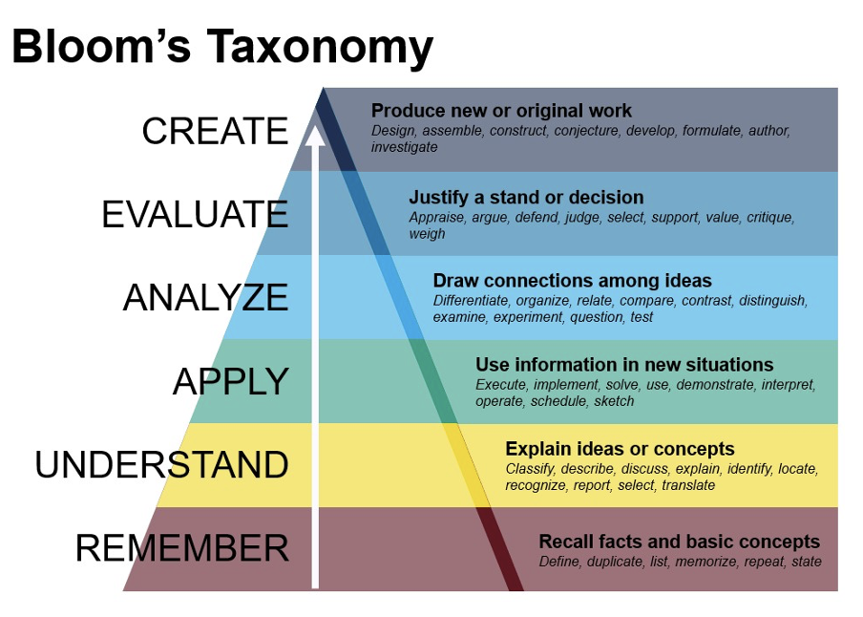

Diagram 1. Bloom's Taxonomy

This model remains vital for:

* **Designing competency frameworks**—clarifying expected learning outcomes.
* **Learning design**—aligning learning objectives and training content with learning activities and assessments, ensuring what is taught is measured appropriately.
* **Supporting adult and professional learning transfer**—balancing knowledge acquisition and practical application.

In 2001, Anderson and Krathwohl updated Bloom’s Taxonomy by identifying two dimensions: the cognitive process and knowledge. Their associated learning progressions are detailed below:

1. The cognitive process dimension

The cognitive process dimension represents the *thinking skills* required to achieve educational outcomes at each level. Each level builds on the previous one, though adult learners may begin at higher levels due to prior experience.

Table 1. Levels of the cognitive process dimension of Bloom's Taxonomy

|  |  |  |  |
| --- | --- | --- | --- |
| Level | Description | Example task words | Activity example |
| 1. Remember | Retrieve relevant knowledge from memory | Define, list, recall, recognize | Name or list concepts, identify a workplace problem |
| 2. Understand | Construct meaning from messages, including oral, written, and graphic communication | Summarize, explain, classify, infer | Describe or explain a concept to peers |
| 3. Apply | Use information or procedures in new situations | Implement, carry out, use, execute | Solving a workplace problem using a standard method or Simulated workplace task |
| 4. Analyze | Break material into parts to understand structure and relationships | Differentiate, organize, compare, deconstruct | Root cause analysis of a workplace issue or Peer review of professional practice |
| 5. Evaluate | Make judgments based on criteria and standards | Critique, judge, defend, appraise | Group discussion on a case study |
| 6. Create | Combine elements to form a novel or coherent whole | Design, construct, generate, develop | Create a new workflow or develop an innovative program |

2. The knowledge dimension

This dimension represents the *type of knowledge* learners are expected to acquire.

Table 2. Types of knowledge in Bloom's Taxonomy

|  |  |  |  |
| --- | --- | --- | --- |
| Type | Description | Example task words | Activity example |
| Factual | Basic elements learners must know | List, recall, recognize | True-or-false quiz on the strengths and challenges of digital health |
| Conceptual | Interrelationships among basic elements | Explain, summarize, differentiate | Draw the workflow of a first-time mother coming to an antenatal clinic |
| Procedural | How to do something (methods, techniques) | Use, execute, construct | Draft a standard operating procedure (SOP) template |
| Metacognitive | Awareness of one’s own cognition and strategies | Critique, defend, generate | Defend how you developed your SOP template—what you included and why, and what you excluded and why |

Understanding the nuances between learning cognitive processes and knowledge dimensions is relevant to adult learning, where learners bring rich life experiences, workplace skills, and self-directedness.

Key considerations when leveling learner outcomes for adult learners:

* Scaffolding can be more flexible—entry-level competencies determine where to start learning.
* Relevance and application are critical—higher-order levels (apply, analyze, evaluate, create) often need prioritization in adult learning.
* Reflection and self-awareness support deeper learning—aligning with the "Create" level.

Assessment alignment

It is important to measure the achievement of these outcomes through relevant assessment strategies. The following basic categorizations align types of assessments to the appropriate taxonomy levels:

* **Low-level**: Quizzes, basic recall tests.
* **Mid-level**: Performance tasks, practical demonstrations.
* **High-level**: Portfolios, presentations, problem-solving exercises.

The focus of I-LEAD is to move learners toward the higher levels—**Evaluate** and **Create**—so they not only grasp knowledge but also **transfer** it to day-to-day work as well as to others.

Habit formation: Linking learning to sustainable behavioral change

Understanding concepts is only the first step; effective training ensures learners sustain behaviors. A four-stage cycle—Learn, Do, Reflect, Act—supports habit formation, as illustrated in the continuous loop in Diagram 2 below.

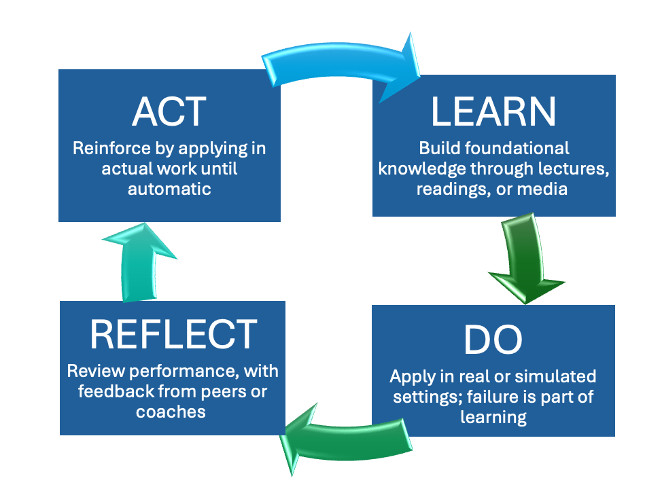

Diagram 2. Habit-forming process

Table 3 presents the core focus of each stage in the cycle, its added value in the habit-forming process, and how it links to the next stage. It is important to note the cyclical nature of this model and to remember that habit formation takes time and sustained effort.

Table 3. Stages of the habit-forming process

|  |  |  |  |
| --- | --- | --- | --- |
| Stage | Core focus | Habit principle | Example |
| Learn | Absorb foundational knowledge (theories, facts, procedures) through content delivery | Build mental models and cognitive frameworks that explain the “what” and “why” behind the habit | Watching videos or animations in a mobile app that explain HIV, how ART works, and the importance of viral suppression; receiving SMS-based educational messages tailored to new diagnoses |
| Do | Apply the practice or behavior in real-world or simulated environments | Begin consistent execution by repeating specific behaviors to create muscle memory while allowing failures to reinforce new behavior | Using a medication reminder app to take antiretroviral therapy (ART) at the same time daily; logging pill intake in a digital diary; participating in virtual adherence counseling via telehealth |
| Reflect | Pause to review the “Do” stage and gather feedback on strengths and gaps | Adjust through reflection on strengths and gaps to achieve sustainable behavioral change and habit formation | Reviewing missed doses in the app and discussing reasons in virtual support groups or with a case manager; using app-based quizzes or mood trackers to understand the impact of mental health on adherence |
| Act | Reinforce in real life to make habits automatic | Repeat and strengthen by conducting tasks repeatedly in real-world settings over time. Positive reinforcement helps sustain habit formation | Taking ART daily without needing reminders; receiving motivational SMS or app-based rewards for adherence milestones (e.g., a 30-day streak); integrating medication into daily routines such as meals or brushing teeth |

At this point, the cycle returns to Learn, but now the knowledge and behavior are more refined. Over time, repeated movement through the cycle creates automaticity, turning conscious actions into habitual behavior.

This habit-forming model is particularly relevant for adult learning because it:

* Emphasizes experiential and reflective learning.
* Recognizes the need for application and feedback.
* Supports self-directed learning and growth through iteration rather than perfection.
* Encourages behavioral change.

Here are the basic principles and actions that will help learners turn what they “Learn” into lasting habits:

* Make learning **relevant and practical** with real-world cases.
* Use **simple job aids** to support recall and use.
* Provide **repetition** through exercises, role plays, and follow-up tasks.
* Build **accountability** through coaching or peer check-ins.
* Offer **recognition and rewards** to encourage consistency.

Adult learning principles

The six principles and their application in I-LEAD

The diagram below visually represents six core principles of adult learning, designed to guide facilitators in how to design and deliver impactful learning experiences for adults. These six principles are foundational guidelines that help us understand how adults learn differently from children and what makes training more effective and meaningful for them.

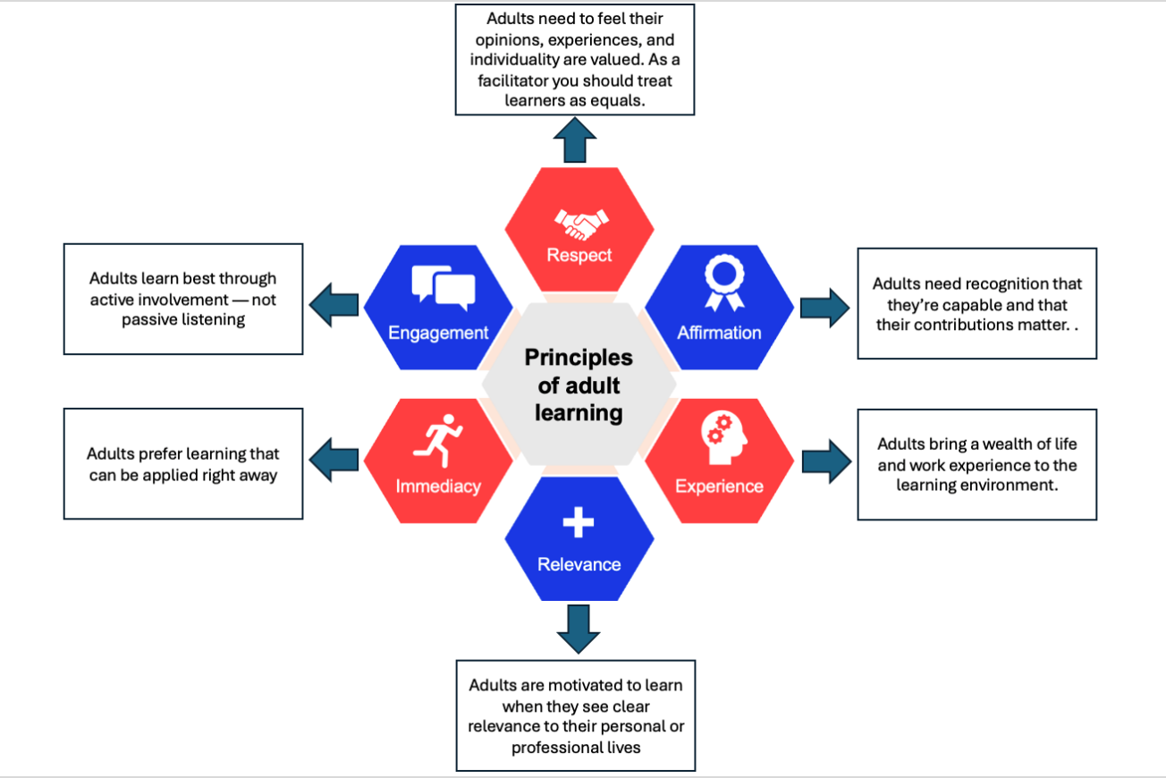

Diagram 3. Principles of adult learning

Surrounding the center are six interconnected principles, each vital in creating engaging, relevant, and lasting adult learning experiences.

1. Respect:

* Treat learners as equals. Avoid talking down to participants, and use collaborative approaches to knowledge generation.
* For example, ask participants to share their perspectives on an issue and use their input to shape how you deliver the planned content. This requires strong facilitation and quick adaptive skills, as you will be shaping content “on the fly.”

1. Affirmation:

* Create a safe space where learners feel confident to speak, try, and sometimes fail at knowledge assessments and practical activities. Provide positive feedback and acknowledge progress even when someone gets it wrong. Emphasize failure as a learning tool rather than a negative consequence.

1. Experience:

* Use learners’ experiences as a resource for illustrating learning by incorporating peer sharing, storytelling, case studies, and reflective discussion into training. In this way, you acknowledge learning through experience. Encourage participants to share failures as well as successes, as both are strong learning tools.

1. Relevance:

* Connect content to real-world problems, job tasks, or personal goals. Include questions such as, “Why is this important to you?” or “How could you use this?” to highlight relevance, particularly with new theoretical content that may take time to grasp.

1. Immediacy:

* Focus on practical tools, strategies, and concepts that offer immediate value in learners’ working lives.

1. Engagement:

* Make learning participatory, dynamic, and learner-driven. You can do this by using discussions, group work, problem-solving, role plays, and interactive technology tools.

By keeping these six principles in mind when designing and delivering training, you:

* Increase learner motivation and retention.
* Encourage real-world application of learning.
* Build trust and create an inclusive, productive learning environment.
* Support the transformation of knowledge into action.

Section 3: Types of learners and learning modalities

Purpose

Understanding how people learn is critical to ensuring the success of capacity-strengthening activities. While the principles of adult learning provide guidance on how best to teach adults, understanding how people learn and internalize information is a key part of designing a training and being a facilitator. This section outlines different pathways of learning and how to consider each in training design.

Visual, auditory, reading/writing, and kinesthetic (VARK)

The VARK model is a framework that describes different learning preferences. Developed by Neil Fleming in the late 1980s, it describes four primary ways of learning: 1) visual, 2) auditory, 3) reading/writing, and 4) kinesthetic, as depicted in the diagram below.

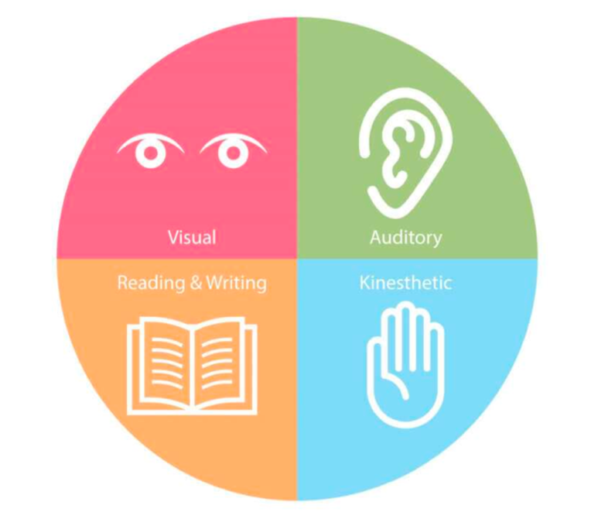

Diagram 4. VARK model: Four primary ways of learning

Each letter in the VARK model represents a primary learning style, as shown in Table 4.

Table 4. Learning styles in the VARK model

|  |  |  |  |
| --- | --- | --- | --- |
| Letter | Learning style | Description | Effective techniques |
| V | **Visual** | Learns best through images, diagrams, charts, and spatial understanding. | Diagrams, color-coded notes, flowcharts, videos. |
| A | **Auditory (Aural)** | Prefers learning through listening, such as lectures, discussions, podcasts, etc. | Discussions, podcasts, group debates, lectures. |
| R | **Reading/writing** | Prefers learning through reading and writing, such as manuals, lists, notes, etc. | Manuals, handouts, written quizzes, journaling. |
| K | **Kinesthetic** | Learns best by doing, including hands-on activities, movement, and real-life examples. | Simulations, role plays, demonstrations, fieldwork. |

The VARK model helps facilitators understand both their own learning preferences and those of their participants. Understanding your own learning style is important for identifying personal learning biases when developing content, while understanding others’ learning styles helps shape how you design training. As a facilitator, you should always assume that your audience represents a mix of VARK preferences and design sessions that appeal to each learning style. Many people are also multimodal, meaning they benefit from a combination of styles rather than from just one.

Please note that VARK describes preferences, not ability. Learning preferences are not rigid, and people can be taught to learn in different ways through the school system and other learning experiences. Learning is often more effective when multiple learning styles are used together.

Types of learners

To strengthen our understanding of how people learn, we will explore the four types of learners in Honey and Mumford’s Learning Styles model, as depicted in Diagram 5, and discuss how they “play out” in a training environment. We will also discuss how to balance training content to ensure each type of learner has an opportunity to succeed.

Diagram 5. Honey and Mumford’s four types of learners

So why does understanding your learners’ learning style matter? It helps you:

* Diversify training to reach different learners.
* Design activities that appeal to multiple preferences.
* Support learners in stepping outside their comfort zones while still ensuring they feel supported.

Learning styles in in-person, live virtual, and self-paced virtual contexts.

Key differences in learning styles between **in-person** and **live virtual training** often stem from the environment, interaction methods, and learner engagement. The table below highlights the key distinctions between in-person, live virtual, and self-paced virtual learning.

Table 5. Key differences in learning styles: In-person vs. live virtual vs. self-paced virtual training

|  |  |  |  |
| --- | --- | --- | --- |
| Category | In-person training | Live virtual training | Self-paced virtual training |
| Learning style fit | Best for **kinesthetic learners** | Best for **visual** and **auditory** learners | Best for **reflective** and **visual learners** |
| Pacing | Fixed, led by the instructor | Fixed, real-time sessions | Flexible, learners control timing and sequence |
| Interaction type | Highly interpersonal, with spontaneous discussions | Moderate, with structured interaction (chat, polls) | Low, mostly self-guided with limited peer interaction |
| Engagement | High, due to physical presence and nonverbal cues | Requires active design to maintain engagement | Risk of low engagement unless learners are self-motivated |
| Feedback | Immediate and informal | Near-immediate, through chat or voice | Delayed, often through automated quizzes or email/forums |
| Technology dependence | Low, limited tools needed | High, requires reliable technology and platform skills | High, requires learning management systems, video, and quizzes |
| Flexibility | Low, tied to time and place | Medium, remote but still time-bound | High, learn anywhere, anytime |
| Support for collaboration | Strong, with face-to-face group work and networking | Moderate, through breakout rooms or shared documents | Low, typically individual, with optional forums |
| Instructor presence | Strong, with physical presence | Moderate, visible but screen-mediated | Weak, may be absent entirely or only through prerecorded content |
| Content delivery | Verbal, hands-on, printed material | Digital, with slides, video, and screen sharing | Asynchronous, with videos, readings, and interactive modules |

In summary, each format supports different learning preferences:

* In-person: Best for hands-on, collaborative learning with high interpersonal engagement.
* Live virtual: Good compromise; supports real-time learning with flexibility but requires engagement tools.
* Self-paced virtual: Ideal for autonomous learners who value flexibility and control but lack immediate interaction.

Cross-referencing with the VARK learning styles shows that:

1. Visual learners thrive in live virtual and self-paced virtual training formats that use slides, videos, and infographics.
2. Auditory learners thrive in virtual and in-person environments with live discussions and lectures.
3. Reading and writing learners thrive in self-paced virtual environments.
4. Kinesthetic learners thrive in in-person environments with physical activity, hands-on tasks, or real-world simulations. Virtual environments must intentionally include interaction or simulations to support this style.

Section 4: Designing a training session

**Purpose**

The purpose of this section is to provide facilitators with guidance to effectively plan and customize I-LEAD content for their workshops and, where relevant, coaching sessions.

The training cycle

The training cycle depicted below presents the development and implementation of training as a five-step process. This section explains each step and why it is important.

The diagram below illustrates the training cycle and summarizes what each step is about.

Diagram 6. The basic training cycle

Things to remember when working through the training cycle:

* Learning objectives should be SMART (Specific, Measurable, Achievable, Relevant, and Time-bound), especially if you plan to assess achievement in quantifiable terms.
* Capture lessons learnt, quiz/test results, and activity feedback from live sessions. This information is critical for the fifth step of the cycle.
* Remind learners that the better the quality of feedback they provide, the better the quality of training they will receive.

Targeting and structuring content

Bulls-eye model (Must Know/Should Know/Could Know)

When presenting a large volume of information in limited time to diverse audiences—such as health workers, developers, politicians, economists, or infrastructure specialists—it is essential to clarify the specific knowledge and actions you want participants to take away. This section outlines how to categorize training content to ensure you communicate your main points clearly to the audience.

The "Must Know, Should Know, Could Know" framework streamlines training design by prioritizing the most relevant content according to learner needs, time constraints, and objectives. This ensures that essential information is delivered efficiently, preventing overload and maximizing impact. For content developers and facilitators, it is a practical tool for focusing training on what matters most.

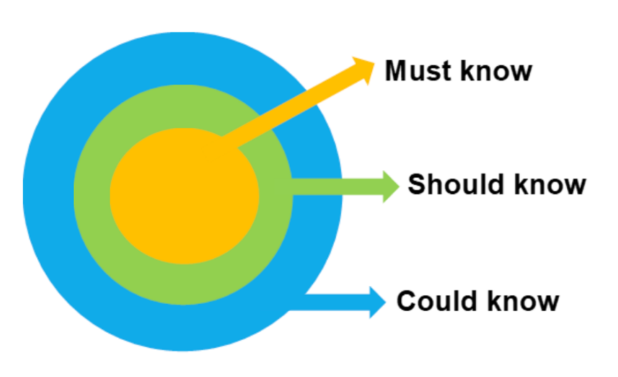

Diagram 7. The bull's-eye model for prioritizing training content

This framework (illustrated above) breaks down training content into three categories—Must Know, Should Know, and Could Know—that content developers and facilitators can use to tailor content for their audience, especially when simplifying highly technical or specialist knowledge for diverse groups. To sort content into the three categories, ask the following questions:

* “What do they need to be able to do immediately?” → Must Know
* “What would help them do it better or faster?” → Should Know
* “What’s interesting but not essential?” → Could Know

The following table summarizes the categories, their purposes, and characteristics:

Table 6. Summary of Must Know, Should Know, and Could Know content categories

|  |  |  |  |
| --- | --- | --- | --- |
| Category | Description | Purpose | Characteristics |
| Must Know | Critical content that learners need to perform their job effectively | Ensures learners meet minimum competency | Essential for all participants. Deliver early in the training and reinforce with practice. Primary focus for assessing competence and evaluation |
| Should Know | Important content that adds depth and improves performance | Enhances understanding and job effectiveness | Include in the workshop, but it is less critical for assessment. Takes more time and could be done through follow-up modules or coaching |
| Could Know | Useful but not essential content | Supports long-term growth or advanced learners | Offer as optional resources or bonus content for advanced learning |

Adjusting technical content for diverse audiences

Adjusting technical content for different audiences is a critical skill in instructional design, communication, and training. The goal is to maintain accuracy while ensuring clarity and relevance for each audience’s background, needs, and goals.

Before adjusting any content, answer the following questions about your audience:

Table 7. Key audience questions for adjusting technical content

|  |  |
| --- | --- |
| Question | Why it matters |
| What is their technical background? | Determines how detailed or simplified the content should be |
| What are their roles or job functions? | Ensures the content is relevant and applicable |
| What do they need to do with the information? | Focuses on practical application versus theoretical understanding |
| What is their familiarity with jargon? | Guides the use of terminology or the need for definitions |
| What is their motivation or reason for learning? | Allows tailoring of tone, pace, and focus |

While all audiences are unique, they can be generalized into four basic types:

* Executives and senior-level managers (e.g., ministers, directors, heads of department).
* Technical specialists (e.g., cybersecurity specialists, neurosurgeons).
* Nontechnical staff (e.g., facilitators, trainers, professional development officers).
* End users/general public.

The table below summarizes how to tailor content to each audience.

Table 8. Tailoring content to different audiences

|  |  |  |  |
| --- | --- | --- | --- |
| Audience | Focus | Use | Avoid |
| Executives and senior-level managers | Outcomes, business impact, high-level overviews | Visuals, diagrams, dashboards, and short summaries | Technical jargon and detailed specifications |
| Technical specialists | Technical details, logic, and specifications. They want precision | Diagrams, workflows, data flows, and detailed content | Oversimplification |
| Non-technical staff | Practical use, simplified explanations, and real-life examples | Analogies, step-by-step guides, visuals, and demonstrations | Abstract logic without context |
| End users/general audience | Benefits, how-to steps, and intuitive explanations | Plain language, simple step-by-step workflows, and job aids | Acronyms and excessive details |

Remember, however, that while useful, the above are generalizations, and facilitators should avoid a one-size-fits-all approach. To ensure sustainable impact:

* Create different versions of the same content for different audiences.
* Test content by running it past someone in the target audience to check for clarity and relevance.
* Ensure accessibility by using clear layouts, readable fonts, and simple language.

The following table presents suggested techniques for tailoring training content.

Table 9. Techniques for tailoring training content

|  |  |
| --- | --- |
| Technique | How it helps |
| Layered information (building knowledge over time) | Start with a summary, then provide more detail as needed |
| Analogies and metaphors | Help non-experts understand abstract concepts |
| Visual aids (diagrams, flowcharts, infographics) | Make complex information easier to understand |
| Glossaries or tooltips | Support comprehension of technical terms |
| Examples and scenarios | Bridge the gap between theory and practice |
| Audience-specific formatting | Tailor content for executives (summaries), developers (detailed documentation), or end users (guides) |

Session planning

Once you have identified and prioritized your training content, the next step is to design how it will be delivered. This section focuses on how to select the right training tools and deliver them effectively.

Selecting methods: presentations, discussions, simulations, and case studies

Selecting the right training methods and tools requires aligning them with instructional goals, learner needs, content type, and delivery context. A structured selection process ensures tools are chosen not for trends or convenience but for their actual fit for purpose.

The following table presents qualifying criteria for selecting delivery methods, explains why they matter, and links them to key questions facilitators should ask while delivering training.

Table 10. Qualifying criteria for selecting training delivery methods

|  |  |  |
| --- | --- | --- |
| Qualifying criteria | Why it matters | Key questions for facilitators |
| Learning outcome alignment | Supports desired knowledge, skills, and attitudes | Does the tool directly support what learners need to know, do, or feel by the end of the training? |
| Learner profile and access | Fits learner needs, devices, and digital literacy | Can learners easily access and use the tool, regardless of their location, technology skills, or devices? |
| Content type fit | Matches the format and complexity of the content | Does the tool support the required delivery format and depth? |
| Interactivity level | Enables engagement, practice, and collaboration | Do learners need to interact, collaborate, or receive feedback in real time? |
| Scalability and sustainability | Can grow with your needs and be reused | Can the tool scale with audience size and be reused or updated easily? |
| Assessment and data tracking | Measures success and provides actionable data | Does the tool allow measurement of learning and tracking of outcomes? |
| Cost and resource efficiency | Stays within budget and available team capacity | Is the tool cost-effective and within available resources? |
| System integration | Works with existing tools and platforms | Does the tool integrate smoothly with the current technology stack (LMS, HRIS, CRM, etc.)? |

Abbreviations: CRM, Customer Relationship Management; HRIS, Human Resource Information System; LMS, Learning Management System.

The following example illustrates how the designers of I-LEAD implemented this process when selecting the “Marshmallow Challenge” for the “Ways of Thinking: Thinking Hats” section of the I-LEAD workshop.

Table 11. Example of applying selection criteria—the Marshmallow Challenge

|  |  |  |
| --- | --- | --- |
| Criteria | Key questions for facilitators | I-LEAD team answers |
| Learning outcome alignment | Does the tool directly support what learners need to know, do, or feel by the end of the training? | Yes. Learners will apply the different ways of thinking to a complex task: building a tower with limited resources |
| Learner profile and access | Can learners easily access and use the tool, regardless of their location, technology skills, or devices? | Yes. The task instructions are clear and straightforward, using simple, portable resources that are easy to work with |
| Content type fit | Does the tool support the required delivery format and depth? | Yes. Because the workshop is in person, a group activity requiring physical building will work well. |
| Interactivity level | Do learners need to interact, collaborate, or receive feedback in real time? | Yes. This is a group activity, where learners will have to interact as a team. It will build relationships among participants as well as teach a lesson |
| Scalability and sustainability | Can the tool scale with the audience size and be reused or updated easily? | Yes. While group size is limited, multiple groups can run in parallel as long as resources are available |
| Assessment and data tracking | Does the tool allow facilitators to measure learning and track outcomes? | Yes. There is a clear success or failure point: whose tower is the highest at the end of the allocated time |
| Cost and resource efficiency | Is the tool cost-effective and within available resources? | Yes. Consumable resources (spaghetti) are inexpensive and easy to obtain, while non-consumable resources (scissors) are commonly available |
| System integration | Does the tool integrate smoothly with the existing technology stack (LMS, HRIS, CRM, etc.)? | Yes. The exercise does not require technology, so it is technology agnostic |

Abbreviations: CRM, Customer Relationship Management; HRIS, Human Resource Information System; LMS, Learning Management System.

Planning for engagement: pacing, transitions, and timing

Planning pacing, transitions, and timing is critical when designing training because it directly affects how well learners:

* Stay engaged.
* Absorb information.
* Retain knowledge.
* Apply what they have learned.

If content is delivered too quickly or monotonously, the audience will lose attention, and they will stop learning. Here are a few things to bear in mind when planning a workshop flow:

* Learner engagement
* Poor pacing (too fast or too slow) can cause boredom or overwhelm.
* Smooth transitions keep learners focused and mentally present.
* Proper timing ensures that key content receives appropriate emphasis.
* Learning load management
* Learners can absorb only a limited amount of new information at once.
* Good pacing allows time for processing, reflection, and questions.
* Transitions signal shifts in topic or tone, preventing overload.
* Maximization of training time
* Time is limited, especially in corporate or live sessions.
* A well-paced session covers all material without rushing or dragging.
* A well-paced session also helps facilitators manage group activities, Q&A, and breaks effectively.
* Improvement of learning outcomes
* Timing activities well (such as practice or discussions) reinforces retention.
* Logical transitions support storytelling and knowledge scaffolding.
* Balanced pacing helps different learning styles stay in sync.

Pacing, transitions, and timing should be considered from the first stage of the training cycle—identify learning requirements. Trying to deliver too much content in too little time is a common error in training workshops, regardless of content complexity or participants’ familiarity with the field of study. Below is a six-step process facilitators can use to plan their workshop delivery.

1. Start with clear learning objectives:

* What do learners need to know or do by the end?
* Prioritize high-impact content to ensure it receives enough time.

1. Break content into logical segments:

* Divide training into chunks (e.g., 10–20 minutes per topic).
* For each segment, define:

1. Content (what will be taught).
2. Method (how it will be taught, e.g., video, demonstration, activity)
3. Timing (how long it should take).
4. Plan transitions intentionally and signal changes with:

* A summary of the previous section.
* Reflection or bridging questions.
* Visual cues (e.g., new slide, video, or activity).

1. Build in interaction and breaks:

* Include check-ins every 15–20 minutes to reset attention (e.g., polls, questions).
* For longer sessions, plan short breaks every 60–90 minutes.
* Use activities or discussions to reinforce content and vary the pace.

1. Build in time buffers:

* Allocate extra time for:

1. Questions.
2. Technical issues (for virtual sessions).
3. Group activities that may run for a long time.

* Do not schedule to the minute; stay flexible.
* Never schedule more than six hours of content delivery in one workshop day.

1. Pilot and adjust (when possible):

* Run a test delivery or dry run.
* Time each section and note where it felt rushed or slow.
* Adjust the pacing plan before the final delivery.
* During training, use end-of-day debriefs with facilitators to review and revise timing for the following day as needed.

The best way to structure and deliver training is to build a facilitator’s agenda during planning. This differs from the training agenda shared with participants, as it contains far more information. The following table provides an example of a facilitator’s training agenda template:

Table 12. Example of a facilitator's training agenda template

|  |  |  |  |  |
| --- | --- | --- | --- | --- |
| Time | Topic/segment | Learning objective | Delivery method | Facilitator notes/materials (include document links) |

|  |  |  |  |  |
| --- | --- | --- | --- | --- |
| 9:00–9:15 AM | Welcome and icebreaker | Set the tone, build rapport, and introduce session objectives | Live facilitation/group activity | Slide deck, introductory slides, icebreaker prompt |
| 9:15–9:30 AM | Training overview | Understand the goals and structure of the session | Presentation | Slide deck, agenda handout |
| 9:30–10:00 AM | Topic 1: [Insert Topic] | Explain core concept A and its relevance | Demonstration/slide presentation | Concept slides, visual aids |
| 10:00–10:20 AM | Interactive activity 1 | Apply the concept through a hands-on or scenario-based task | Group exercise/breakout | Worksheets, virtual whiteboard |
| 10:20–10:30 AM | Debrief and transition | Reflect on the activity and prepare for the next concept | Group discussion | Key takeaways slide |
| 10:30–10:45 AM | Break | Give learners time to refresh | — | — |
| 10:45–11:15 AM | Topic 2: [Insert Topic] | Introduce and explore concept B | Slide presentation and Q&A | Visual examples, real-life cases |
| 11:15–11:35 AM | Knowledge check/quiz | Reinforce understanding and gauge retention | Quiz/poll/review game | Quiz tool (e.g., Kahoot, Learning Management System [LMS] quiz) |
| 11:35–11:50 AM | Application activity 2 | Practice new skills or decision-making | Scenario, simulation, or case study | Case handouts, breakout rooms |
| 11:50–12:00 PM | Wrap-up and next steps | Recap key takeaways and set expectations for post-training | Summary and action planning | Summary slide, resource links |

Section 5: Facilitating learning

Purpose

The purpose of this section is to provide facilitators with guidance on the core skills, characteristics, and tools needed to successfully implement an interactive workshop such as I-LEAD.

Core facilitation skills

Facilitation skills

Facilitators are not just presenters; they are guides, coaches, and connectors who help learners engage with content and apply it effectively. Whether in person or virtual, strong facilitation depends on a combination of communication, instructional, and interpersonal skills. Here is a list of core skills every training facilitator should have:

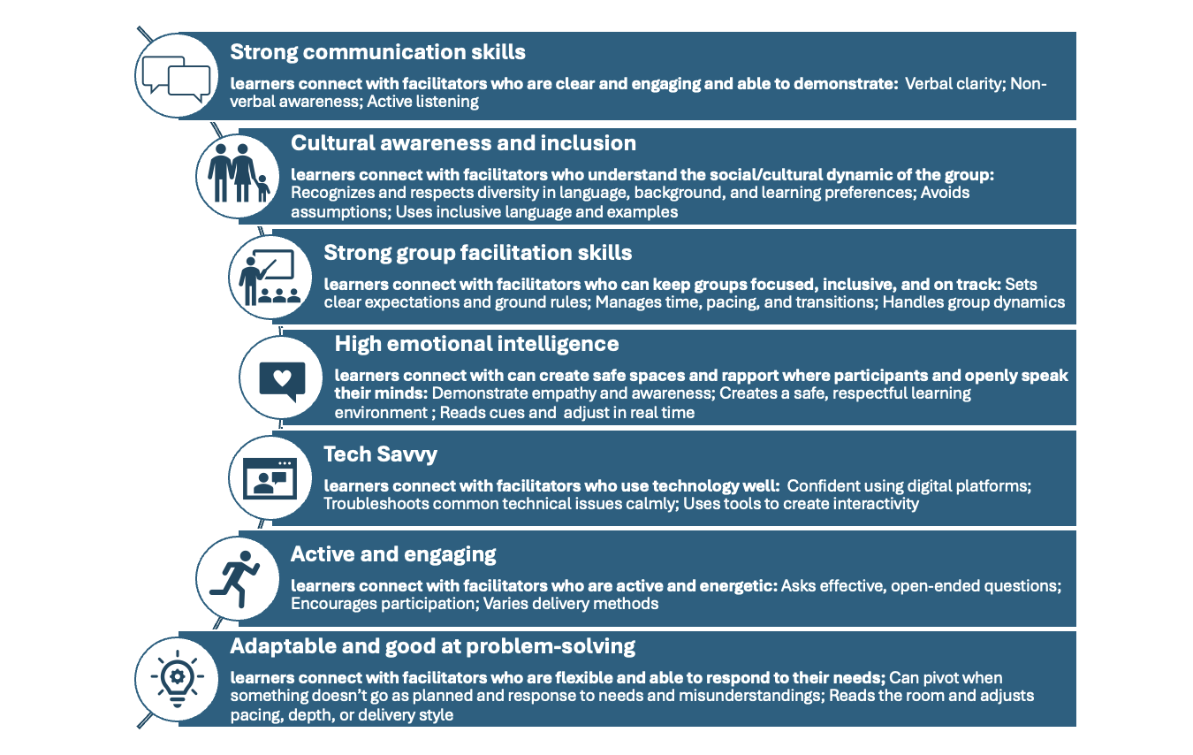

Diagram 8. Core skills of a good facilitator

Body language, voice modulation, handling difficult questions, and inclusivity

Body language and voice modulation are powerful communication tools in training facilitation. They significantly influence how messages are received, how engaged learners are, and how confident and credible facilitators appear.

Body language

Body language is a critical nonverbal indicator of confidence, approachability, and interest, and facilitators can use it to:

* Reinforce messages: Gestures and posture add emphasis and clarity.
* Build trust and rapport: Open body language creates a welcoming atmosphere.
* Show confidence and credibility: Physical presence influences how learners perceive authority.
* Engage learners: Movement and eye contact keep learners visually attentive.
* Signal enthusiasm: Energy helps motivate and sustain learner interest.

To keep participants engaged and physically involved as content is delivered, facilitators should:

* Use open gestures to emphasize key points.
* Make eye contact with different participants (or with the camera in virtual settings).
* Use purposeful movement to shift focus or transition topics.
* Smile genuinely to convey warmth and openness.

The following table highlights body language cues to avoid when facilitating training:

Table 13. Body language cues to avoid when facilitating training

|  |  |
| --- | --- |
| Mistake | Why it is a problem |
| Crossed arms/closed posture | May appear defensive or unapproachable |
| Lack of eye contact | Reduces connection and can feel impersonal |
| Excessive pacing or fidgeting | Distracting and signals nervousness |
| Hands in pockets | Appears disengaged or lacking confidence |
| Standing still for too long | Reduces energy and makes delivery flat |

Voice modulation

Voice modulation allows facilitators to connect with their audience in the same nonverbal way as body language. A strong, clear voice conveys confidence and authority, while a soft, hesitant voice may struggle to manage a room or be taken seriously. In addition to maintaining audience attention, voice modulation can act as a verbal highlighter for content, and changes in pitch, speed, and tone can:

* Add interest and emphasis to what is being said.
* Maintain audience attention, prevent monotony, and keep learners engaged.
* Communicate emotions such as enthusiasm, urgency, or empathy.
* Clarify meaning by using pauses and stress to distinguish between concepts or steps.

The following techniques in voice modulation can help keep the audience active, engaged, and learning:

* Use variations in pitch and tone to add emphasis and keep delivery lively.
* Pause intentionally after important points or questions.
* Match tone to message (e.g., serious when discussing safety, upbeat when motivating).
* Speak clearly and at a moderate pace to support comprehension.

The following table highlights some common mistakes facilitators make with voice modulation and why they matter:

Table 14. Common voice modulation mistakes

|  |  |
| --- | --- |
| Mistake | Why it is a problem |

|  |  |
| --- | --- |
| Monotone delivery | Boring and sleep-inducing; reduces retention |
| Speaking too fast | Overwhelms learners; hard to follow |
| Speaking too softly | Difficult to hear, especially in large or virtual rooms |
| Overuse of filler words (e.g., "um," "like," "you know") | Undermines professionalism and flow |
| Yelling or over-projecting | May feel aggressive or cause discomfort |

When body language and vocal delivery align, learners are more likely to trust, remember, and act on the content being delivered, as the training will feel more authentic, dynamic, and engaging.

Handling difficult questions

Handling difficult or contentious questions as a facilitator is a crucial skill. It requires balancing authority, empathy, and control of the learning environment. A facilitator’s response can either deepen trust and engagement or derail the session and erode credibility.

To handle difficult or contentious questions professionally and effectively, facilitators should:

1. **Stay calm and composed:**
2. Pause before responding to allow time to think.
3. Maintain neutral body language and a respectful tone, even if the question feels confrontational or emotional.
4. A facilitator’s demeanor sets the tone. If the facilitator stays respectful and composed, others are more likely to follow.
5. **Acknowledge the question respectfully:**
6. Show that the question has been heard and valued, even if it is off-topic or challenging.
7. Use neutral, validating phrases such as:

* “That is a valid concern.”
* “I appreciate you raising that.”
* “That is an important perspective.”

1. **Assess the intent:**
2. Determine whether the question is:

* Genuinely curious or confused.
* Constructively challenging the material.
* Emotionally charged due to personal experience.
* Disruptive or agenda-driven.

1. Tailor the response to the underlying motivation, not just the words.
2. **Respond constructively:**
3. If it is a legitimate but challenging question:

* Provide a fact-based, honest answer.
* If the answer is complex or unavailable, examples of appropriate responses include:
* “That’s a great question. I want to provide a complete answer, so let me follow up with you after the session.”
* “Let us explore that as a group. What do others think?”

1. If it is off-topic but important, park the question in a “parking lot” (a place for valuable but non-core topics). For example, you can say, “That’s a really good topic. Let us note it down and return to it at the end if time allows.”
2. If the question is contentious or opinion-based, reframe it to align with the session’s purpose. For example, you can say:

* “That is a broader issue than what we are focusing on today, but I appreciate your input.”
* “There are differing views on that. For today’s training, we are using the framework provided by [organization/policy/industry standard].”

1. **Defuse emotion and conflict:**
2. If a participant is argumentative, respond without escalating. Examples of appropriate responses include:

* “Let us keep the discussion focused on learning and respectful dialogue.”
* “I understand there are strong feelings here. Let us take a short break and come back to this afterward.”

1. Use private follow-up if necessary. For example, you can say, “Let us talk one-on-one after the session to explore that further.”
2. **Set boundaries if needed:**
3. Facilitators are responsible for maintaining a safe and respectful learning environment. If someone is disruptive, politely but firmly redirect. For example, you can say:

* “Let us take this offline so we do not lose momentum.”
* “I will need to move us along to stay on schedule. Thank you for understanding.”

This process may sound simple, but when emotions run high, a room can quickly get out of control. The following are some examples of how to respond to difficult questions:

Table 15. Examples of difficult questions and responses

|  |  |
| --- | --- |
| Question | Response |
| “This training is useless. We already know this.” | “Thank you for sharing. We will explore advanced applications later in the session.” |
| “Your data is wrong. I read something different.” | “That is interesting. Could you share your source after the session? This data comes from [source].” |
| “Why is our company even doing this?” | “That is a strategic decision beyond today’s scope, but I encourage you to speak with [appropriate person].” |
| “I completely disagree with what you just said.” | “I appreciate your perspective. We will look at the rationale behind this approach and discuss it further.” |

Making sessions interactive

Interactions with participants are critical to ensuring the successful delivery of adult learning training. Selecting icebreakers and activities that allow participants to experience or demonstrate what they are learning is an important part of running an engaging and impactful in-person training session. This section explains the difference between an icebreaker and a learning activity and provides guidance on how and when to use them.

Icebreakers vs. learning activities

The difference between an icebreaker and a learning activity lies primarily in their purpose, timing, and focus within a training session or workshop.

The icebreaker

Icebreakers warm up the group, reduce tension, and create a comfortable environment. They help participants get to know one another and begin engaging. They are typically used at the start of a session or before transitioning into heavier content. The focus of icebreakers is on people and relationships, not on training content, and they are designed to encourage participation, trust, and engagement.

A good icebreaker in in-person training sets the tone, energizes the group, and creates a foundation for engagement. The following are key characteristics of an effective icebreaker:

1. Encourages interaction:
2. Promotes conversation and collaboration among participants.
3. Gets people talking who may not already know each other.
4. Low-pressure and inclusive:
5. Avoids putting people on the spot or making them feel uncomfortable.
6. Suitable for all personality types (e.g., extroverts, introverts).
7. Avoids requiring personal disclosures unless the group already knows one another well.
8. Time-conscious:
9. Fits within the first 5–15 minutes of the session.
10. Leaves participants feeling energized, not drained.
11. Builds trust and comfort:
12. Helps participants feel safe and welcome in the room.
13. May include light humor or shared experiences to create common ground.
14. Simple and easy to follow:
15. Requires minimal explanation or materials.
16. Participants can quickly understand what to do and engage right away.
17. Sets the tone:
18. Reflects the energy and tone desired for the rest of the training (e.g., creative, collaborative, focused).
19. Engages thinking or creativity:
20. Encourages curiosity, sharing of ideas, and looking at things from new perspectives.
21. Especially helpful in problem-solving or innovation-focused training.

Examples of icebreakers that fit these traits are:

* "Human Bingo" (interactive and movement-based).
* "Build Your Story" (good for energy and engagement).
* “Build Your Picture” (good for energy and engagement in a multilingual setting).

A good icebreaker for live virtual training needs to account for the unique challenges of online environments, such as screen fatigue, limited body language cues, and varying technology familiarity, while still achieving the core goal of making participants feel comfortable, engaged, and ready to learn. The following are additional key characteristics to consider when designing a strong virtual icebreaker:

1. Tech-friendly and accessible:
2. Works smoothly with common virtual tools (e.g., Zoom, Microsoft Teams, Webex).
3. Does not require advanced technical skills or complicated platforms.
4. Uses features such as chat, reactions, breakout rooms, polls, and whiteboards intentionally.
5. Short and time-conscious:
6. Lasts 5–10 minutes at most to maintain energy and keep the session on schedule.
7. Avoids dragging or overcomplicating the opening.
8. Low-stakes and convenient:
9. Encourages voluntary participation and multiple modes of input (e.g., chat, reactions, audio).
10. Promotes human connection:
11. Helps participants feel like they are not just names on a screen.
12. Encourages personal sharing within safe, appropriate limits.
13. Interactive and engaging:
14. Requires participants to do something, not just observe.
15. Uses visual, verbal, or written participation to engage participants early.
16. Inclusive across locations and cultures:
17. Avoids culturally specific references or humor that may not be translated well.
18. Keeps language and activities neutral and universally accessible.

The following are examples of icebreakers that fit these traits:

* Quick polls (e.g., “What is your favorite way to start the day?” Options: coffee, workout, reading, etc.).
* Emoji check-ins (e.g., "Drop an emoji in the chat that describes your current mood.").
* Speed introductions in breakouts: 2–3 people in a breakout room, 2 mins each (e.g., “State your name, role, and one thing you’re looking forward to this week.”).

The learning activity

Learning activities teach, reinforce, and apply the training content or skills. They are designed to help participants understand, practice, and internalize learning objectives. Learning activities focus on delivering content and aim at developing knowledge, building skills, and exploring concepts. They bridge theory with real understanding and skill-building. The key characteristics of effective in-person learning activities are:

1. Alignment with learning objectives:
2. Directly supports the goals of the session.
3. Participants should be able to apply knowledge and demonstrate understanding afterward.
4. Purposeful and relevant:
5. Clearly connected to real-world tasks, challenges, or decisions participants face.
6. Helps answer the question: “Why does this matter to me?”
7. Interactive and engaging:
8. Encourages active participation, not passive listening.
9. Promotes discussion, collaboration, or hands-on practice.
10. May include group work, pair exercises, simulations, or role plays.
11. Promotes critical thinking and skill use:
12. Challenges participants to analyze, evaluate, problem-solve, or create.
13. Goes beyond rote memorization or simple repetition.
14. Encourages peer learning:
15. Leverages the group dynamic by allowing people to learn from each other.
16. Supports dialogue, not only trainer-to-participant instruction.
17. Appropriately scaled:
18. Fits the time available and the complexity level of the learners.
19. Avoids cognitive overload or dragging on too long.
20. Provides feedback and reflection:
21. Includes some form of debrief, discussion, or self-assessment.
22. Helps participants consolidate learning and see where they stand.
23. Uses available resources effectively:
24. Designed with the physical space, materials, and group size in mind.
25. Takes advantage of in-person tools like flip charts, props, or body movement.
26. Safe and inclusive:
27. Respects different learning styles and comfort levels.
28. Avoids putting anyone on the spot without preparation or consent.

Examples of learning activities that fit these traits include:

* Role-play: Participants act out a situation (e.g., giving feedback to a peer).
* Simulation or game: Model real processes (e.g., decision-making under pressure).
* "Teach-back": Learners explain a concept to each other.
* Gallery walk: Groups create posters summarizing key points, then walk around to learn from others.

Virtual training needs differ from those of in-person training. A good live virtual learning activity blends interactivity, clarity, and purpose while accounting for the realities of remote engagement (such as screen fatigue, technical issues, and limited nonverbal cues). The following are additional key characteristics to consider when designing a strong virtual learning activity:

1. Designed for the virtual format:
2. Leverages available platform tools (e.g., breakout rooms, polls, chat, whiteboards, shared documents).
3. Considers technical limitations and avoids overcomplicated instructions or tool overload.
4. Works smoothly with different internet speeds, devices, and levels of technical confidence.
5. Interactive and collaborative:
6. Requires participants to actively contribute rather than only watch.
7. Often involves peer interaction in breakouts, pairs, or group discussions.
8. Encourages multiple forms of engagement (e.g., speaking, typing, drawing).
9. Time-conscious and well-paced:
10. Fits within the session’s timeline without rushing or dragging.
11. Includes time for task completion, sharing, and a brief debriefing.
12. Clear transitions into and out of the activity help maintain flow.
13. Encourages thinking and skill application:
14. Goes beyond passive recall and asks learners to analyze, synthesize, or apply.
15. Ideally mirrors real-world situations participants might face in their roles.
16. Clear instructions and structure:
17. Instructions are short, specific, and visible (spoken and shared in chat or slides).
18. The activity has a defined start, task, and endpoint.
19. Groups or individuals know what success looks like for the task.
20. Safe, inclusive, and supportive:
21. Makes room for all voices and comfort levels.
22. Offers low-pressure ways to contribute (chat versus microphone; group versus individual).
23. Avoids activities that could make participants feel exposed or judged.

The following are examples of virtual learning activities with these traits:

* Breakout room scenario—Small groups solve a challenge or analyze a case based on training content.
* Shared Google Doc—Participants brainstorm or categorize concepts together in real time.
* Chat-based quiz or challenge—Participants use chat for fast recall or decision-making exercises.

Table 16 provides a summary comparison of icebreakers and learning activities:

Table 16. Summary comparison of icebreakers and learning activities

|  |  |  |
| --- | --- | --- |
| Aspect | Icebreaker | Learning activity |
| Goal | Build rapport, comfort, and energy | Facilitate understanding and learning |
| Timing | At the beginning or during transitions | After the content is introduced |
| Focus | People, connection, and atmosphere | Training content and skill development |
| Tone | Light, fun, and inclusive | Engaging but content-specific |
| Outcome | Participation and openness | Knowledge acquisition and skill practice |

Final tips for selecting, designing, and using icebreakers and learning activities:

* Use clear and simple instructions to avoid confusion or awkward silences.
* Always model participation or test the activity first (e.g., answer the question yourself).
* Always have a backup plan for technical issues.
* Use co-facilitators or assistants when managing breakout rooms or multiple platforms.
* Acknowledge contributions from chat or verbal responses to build early rapport.
* Recap key takeaways after the activity to reinforce learning.

Microteaching

Microteaching is a scaled-down, practice-based teaching technique in which facilitators deliver short, focused lessons to a small group to receive feedback and improve specific teaching skills. The purposes of microteaching are:

* To provide a safe, low-pressure environment for developing teaching techniques.
* To build confidence and competence in real classroom situations.
* To allow focused improvement on one skill at a time (instead of juggling everything at once).

The key features of microteaching are shown in Table 17.

Table 17. Key features of microteaching

|  |  |
| --- | --- |
| Feature | Description |
| Short duration | Typically 5–15 minutes long |
| Small audience | Usually a small group of peers or students (e.g., 5–10 people) |
| Focused objective | Designed to practice one specific skill (e.g., questioning, explaining, classroom management) |
| Feedback-oriented | Followed by immediate, structured feedback from peers, mentors, or trainers |
| Reteach cycle | Often includes a "teach–critique–reteach" process to refine the skill |

Using microteaching in an adult learning in-person workshop is an excellent way to promote experiential learning, peer feedback, and skill development, especially when the goal is to improve facilitation, presentation, or instructional delivery skills.

To use microteaching effectively in an adult learning workshop context:

1. Set the stage with purpose:
2. Clarify the purpose behind the microteaching activity.
3. Frame it as a safe, supportive practice space, not an evaluation.
4. Emphasize that the focus is on skill development, peer learning, and continuous improvement.
5. Break it into manageable steps. A typical microteaching cycle looks like this:

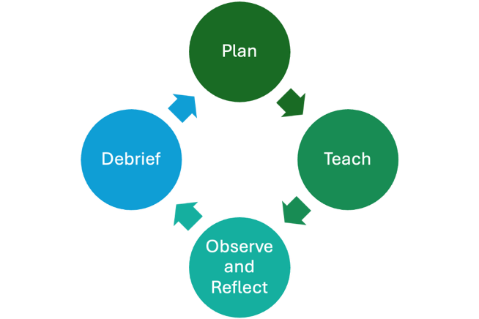

Diagram 9. Microteaching cycle

1. Focus on one or two skills at a time. Ask participants to concentrate on developing specific adult facilitation skills, such as:
2. Explaining concepts clearly.
3. Using open-ended questions.
4. Managing group dynamics.
5. Encouraging participation.
6. Giving instructions effectively to keep the activity focused and achievable.
7. Use structured feedback tools. Provide a simple feedback form or rubric aligned with the skills being practiced. Include prompts such as: “What did the facilitator do well?” or “Where was learner engagement strongest?” This keeps feedback constructive rather than personal.
8. Keep group sizes small:
9. Ideally, 3–5 participants per group.
10. Rotate roles: one teaches, while others observe and provide feedback.
11. This ensures active participation and provides ample feedback opportunities.
12. Manage time tightly:
13. Keep teaching segments short (5–10 minutes).
14. Allow 5–10 minutes for feedback after each round.
15. A tight structure keeps energy high and ensures everyone has a chance to participate.
16. Build psychological safety:
17. Normalize making mistakes, as they are part of the learning process.
18. Model positive, nonjudgmental feedback.
19. Encourage self-reflection: “How did it feel to teach? What would you change next time?”

Gamification strategies

Gamification of training content refers to the application of game-design elements and principles to training or educational material to make it more engaging, motivating, and effective. Gamifying educational content has been shown to:

* Boost motivation and engagement.
* Increase retention of information.
* Encourage consistent participation.
* Make repetitive or complex topics more enjoyable.

The key elements of gamification, or designing a game for delivering training content, are to add:

* **Points and scoring**—Learners earn points for completing tasks, answering questions, or achieving goals.
* **Badges and achievements**—Visual rewards for completing milestones or demonstrating skills.
* **Levels and progression**—Content is structured like game levels, where learners unlock new material as they progress.
* **Leaderboards**—Ranking learners by performance to encourage healthy competition.
* **Quests or challenges**—Framing learning objectives as missions or challenges to solve.
* **Instant feedback**—Learners receive immediate responses to their actions, just like in games.
* **Storytelling or narrative**—Embedding training content within a story to boost emotional engagement.
* **Avatars and customization**—Allowing learners to personalize their learning experience.

While fun and impactful, designing a game from your training content is a complex and time-consuming process. Here are some top tips for gamifying training content:

* **Start with the learning goal, not the game.**
* Every activity should serve a clear purpose.
* Ask yourself, “What do I want them to learn or practice?”
* Avoid games that are fun but off-topic (sometimes called *education without education*).
* **Gamify activities, not just content.**
* Think beyond quizzes—gamification can apply to how you deliver *any* session.
* Turn discussions into team challenges.
* Use role-playing as “missions.”
* Add competitive or collaborative layers to typical exercises.
* **Choose the right game mechanics.**
* Align the game type with the training goals.
* Quizzes/trivia: Use for knowledge recall.
* Simulations: Use for practical, skill-based learning.
* Scenarios or branching stories: Use for decision-making and soft skills.
* Time-based challenges: Use for building speed or handling pressure.
* **Use low-tech game mechanics creatively.**
* You don’t need fancy tools; just smart facilitation.
* Use whiteboards, sticky notes, cards, dice, timers, or simple scoreboards.
* Create scavenger hunts or physical challenges.
* Gamify discussions (e.g., award points for strong arguments).
* **Weave in a story or context.**
* Even a simple narrative can boost engagement and retention.
* Create characters, missions, or scenarios that tie back to real work situations.
* Make learners feel like heroes solving meaningful problems.
* Use rewards strategically.
* Rewards should motivate, not distract.
* Points, badges, and leaderboards work well if learners value them.
* Tie rewards to real-world incentives if appropriate (e.g., certificates, recognition).
* **Build progression and challenge.**
* Just like a good game, your training should feel rewarding and dynamic.
* Start easy, then increase difficulty.
* Use levels, unlockables, or missions to pace content.
* Create a sense of accomplishment.
* **Do not overcomplicate it.**
* More game mechanics do not always mean more fun or more learning.
* Focus on simplicity and clarity.
* Every element should serve the learning goal.
* **Make it accessible.**
* The game should be easy to use across devices and inclusive for all learners.
* Consider accessibility features (e.g., text-to-speech, color contrast).
* Optimize for mobile if needed.
* **Integrate feedback loops.**
* Learners should know immediately whether they made the right or wrong choice.
* Use clear, constructive feedback—not just “correct” or “wrong.”
* Help learners learn from mistakes within the game environment.
* **Playtest and iterate.**
* Test early with a small group of learners or peers.
* Observe how learners engage: Are they learning? Are they stuck? Are they bored?
* Use feedback to improve usability, pacing, or clarity.

When delivering a game during a workshop, facilitators should:

* **Frame the session like a game or journey.**
* Set the tone with narrative and structure.
* **Act as a game master, not just a trainer.**
* The facilitator’s energy and delivery set the tone.
* Build anticipation and excitement.
* Celebrate wins and progress.
* Keep the game moving and adapt as needed.
* **Build in real-time feedback and rewards.**
* Ensure learners know how they are performing and why it matters.
* Give verbal praise, award small prizes, or mark progress on a visual tracker.
* Highlight great answers or teamwork in the moment.
* **Stay flexible and responsive to the room.**
* Some groups enjoy competition, while others may feel uncomfortable. Adjust the energy level up or down depending on group dynamics.
* Use humor and empathy to manage different comfort levels.
* **Debrief every game or activity.**
* The game is the method, but the learning happens in the reflection.
* Ask questions such as, “What did you notice?” or “How did that connect to real work?”
* Tie game outcomes back to key learning points.

Managing audiences

Keeping the audience engaged and learning is the primary role of a facilitator. Understanding the limitations of learners’ attention span is important for planning and implementing training sessions. Diagram 10 below depicts a typical breakdown of workshop session timing to optimize learning effectiveness.

Time breakdown for content, discussion, and review

In general, learners can only absorb new information for up to 20 minutes. After that, optimal learning requires approximately 30 minutes of participation and 10 minutes of review. Presentations longer than 20 minutes should include participation and review, or the content risks being ignored.

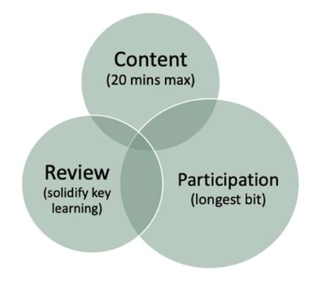

Diagram 10. Preferred time management breakdown

Considering the recommendation to limit session totals to six hours in one day, facilitators should introduce no more than 120 minutes of new content in a full training day. This is why it is important to prioritize content into “must know,” “should know,” and “could know,” so that key lessons are covered within the available “content time.”

In-person: Room setup, breakout rooms, and group dynamics

Having a safe, secure, and quiet place with sufficient space for participants is key to running a successful in-person training. This section offers tips to ensure that rooms are set up correctly and on time, and that the audience can be managed effectively in the physical space.

Main venue setup tips

* Where possible, view the room and breakout rooms before the workshop to plan placement.
* Arrive at the venue early and ensure that the room is set up before participants arrive.
* Keep the layout of the room simple and ensure that all participants can see the presentation screens and other visuals.
* Ensure the layout allows space for participants to move during and between sessions.
* Test audiovisual equipment on the computer designated for presentations, and ensure support staff are available in case issues arise.
* Ideally, use a dedicated machine for presentations during the workshop. This reduces the chance of technical issues when switching between machines with different presentations.
* Bring or request extra plug extensions and adapters for computers and other equipment (projectors, servers, tablets, or other testing devices).
* Have flipcharts, pens, and other materials ready before the workshop. Print extra copies as a precaution.

Additional tips for breakout rooms

* Ensure the room size fits the size of the breakout group.
* Keep breakout rooms close to the main venue to avoid losing time when moving between sessions.
* Provide flip charts, scrap papers, Post-its, pens, and other supplies for participants to use in note-taking and brainstorming.
* Apply the same preparation standards used for the main room.

Group dynamics

Knowing the audience in theory (pre-training) is important, but individual personalities can significantly impact group dynamics. Facilitators are responsible for navigating group dynamics and ensuring that everyone benefits from and engages in the training.

This begins with making a rapid assessment during the opening remarks and icebreaker to identify who is “active,” “loud,” “not engaged,” and “quiet.” Reevaluate this assessment at lunchtime and at the end of the day, as participants’ levels of activity, noise, and engagement will vary as they become more comfortable in the training space.

Signs to look out for that can negatively affect group dynamics, along with tips on how to address them:

* Group hierarchy: In medical and political settings, hierarchies within a group can negatively impact open discussions. Clarifying the value of each participant’s contribution (why they’re there) and creating safe spaces for speaking are important responsibilities of the facilitator.
* Modulating participant engagement: Managing loud participants while encouraging quieter ones can be challenging. Providing different ways to share input—written, verbal, or in small groups—can help balance participation.
* Drops in audience energy: All audiences experience energy drops at some point. Some can be anticipated, such as the after-lunch slump, which facilitators can plan sessions around. Others occur when participants lose interest or become tired. Recognizing when attention has dropped and re-engaging participants through pop quizzes, fun ice breakers, or movement activities is an essential facilitation skill.
* Difficult questions or critical know-it-alls: There is often at least one person in every session who believes they know better or poses difficult questions about the content. See section on managing difficult questions of this document for further guidance.

Section 6: Monitoring learning

Purpose

The purpose of this section is to provide facilitators with guidance on monitoring learning through the use of assessments, evaluations, and reinforcement strategies.

Assessment versus evaluation

Definitions and differences

This section explains the difference between capacity-strengthening activity assessments and evaluations. It provides guidance to facilitators on selecting which approach to use and when and how to assess learners and evaluate activities. It also discusses good practices for assessment and evaluation. The section concludes with an overview of digital tools that can support assessment and evaluation.

For facilitators, understanding the impact of training is critical to establishing success and improving future sessions. There are two primary ways to establish the impact of training: assessments and evaluations.

Assessments

Assessments are processes for measuring a learner’s knowledge, skills, attitudes, or performance before, during, or after a training program to determine what learners already know (pre-assessment) and what they have learned (post-assessment). The purpose of an assessment is to determine the effectiveness of the training and the extent to which learning objectives have been met. Assessments can take many forms, including quizzes, tests, simulations, practical demonstrations, or observations.

Evaluations

An evaluation is a systematic process of collecting and analyzing information to determine the effectiveness, efficiency, relevance, and impact of a training program. It can include assessment data to understand effectiveness, but goes beyond this to capture information about efficiency, quality of delivery, and relevance for learners and participants. All trainings should have an evaluation component. Evaluation data collection is conducted in a similar way to assessments, using quizzes, surveys, simulations, and observations.

These explanations show that an evaluation is broader than an assessment. To fully understand the success of a training program, it is important to include at least some form of assessment as part of the evaluation.

Pre-training and post-training tests, surveys, and real-time feedback tools

Pre-training and post-training tests

Pre-training and post-training tests are assessment tools used to evaluate the effectiveness of a training program by measuring participants’ knowledge, skills, or attitudes before and after the training. They can be defined as follows:

Pre-training test  
This is a test administered before a training session begins to assess participants’ baseline knowledge or skill level.

Post-training test  
This is an assessment administered after the training concludes to measure what participants learned and retained.

Pre-testing and post-testing are formal assessment tools that provide facilitators with quantitative evidence of impact. Depending on the timing of the post-testing, the assessment will show immediate, short-term, or medium-term impact on learning retention. For qualitative information that provides insight into how the training was received by participants, the assessment should be extended into an evaluation that examines impressions of delivery and content, not just the level of retained material.

Survey

A survey is a structured method for collecting information from individuals, usually through a set of questions designed to gather opinions, experiences, perceptions, or feedback. In the context of training, surveys are typically administered after a course or program to gather insights from participants.

Surveys generally include three types of questions:

* **Closed-ended** (e.g., multiple choice, rating scales).
* **Open-ended** (e.g., written feedback).
* **Scale** (e.g., strongly agree to strongly disagree).

They differ from tests in various ways, as detailed in Table 18.

Table 18. Comparison of tests and surveys in training contexts

|  |  |  |
| --- | --- | --- |
| Aspect | Test | Survey |
| Primary purpose | To measure knowledge, skills, or abilities | To gather opinions, perceptions, experiences, or feedback |
| Objective | Assess what someone knows or can do | Understand how someone feels or thinks about something |
| Type of questions | Right-or-wrong answers (e.g., multiple choice, true/false, short answer) | No right-or-wrong answers (e.g., Likert scale, open-ended, multiple choice) |
| Scoring | Typically scored to evaluate performance | Not scored; results are analyzed for trends or patterns |
| Focus | Learning outcomes, competence, readiness | Satisfaction, opinions, attitudes, needs |
| Use case examples | Pre- and post-training tests, school exams, certification exams | Course evaluations, customer satisfaction, employee engagement surveys |

Surveys and tests can be used together to provide a more comprehensive understanding of the impact of training, providing both quantitative and qualitative data to support the evaluation of capacity-strengthening activities.

Real-time feedback tools

Real-time feedback tools are digital or interactive platforms that allow facilitators to gather input, responses, or reactions from participants instantly during a live in-person workshop or training session. These tools enhance engagement and enable facilitators to adjust content, pace, or delivery on the spot based on participant responses.

The key features of real-time feedback tools are:

* Immediate input: Facilitators can collect responses from participants in seconds via phone, tablet, or computer.
* Interactive formats: Facilitators can introduce polls, quizzes, word clouds, Q&A, emoji reactions, and live voting.
* Live displays: Results can be shown in real time on a projector or screen.
* Anonymity options: Participants can respond anonymously, encouraging honest feedback.
* Mobile-friendly: Typically web-based or app-based, requiring no special devices or installations.

These features make real-time feedback an excellent tool for both in-person and live virtual training. The two tables below provide details about the value added by real-time feedback in different workshop types and list possible tools that can be used to create and implement real-time feedback activities.

Table 19. The value of real-time feedback tools in in-person capacity-strengthening activities

|  |  |  |
| --- | --- | --- |
| Value area | Description | Examples/tools |
| Enhances engagement | Transforms passive sessions into interactive experiences, encouraging active involvement from all participants. | Mentimeter, Slido, Kahoot! |
| Immediate comprehension check | Helps facilitators assess whether key concepts are understood in real time and clarify as needed. | Live polls, quizzes, real-time Q&A |
| Encourages participation | It provides everyone, especially quiet or hesitant attendees, with a way to participate anonymously or using their own devices. | Anonymous polls, open-ended questions |
| Enables real-time adaptation | Enables facilitators to adjust pace or focus based on participant responses or feedback during the session. | Polls on clarity or pace, mood meters |
| Facilitates instant feedback | Collects immediate insights on how the session is progressing, enabling continuous improvement throughout the day. | “How are we doing?” pulse checks, emoji meters |
| Supports data collection | Captures participant input digitally for later analysis and evaluation, supporting both formative and summative assessments. | Exportable reports from tools like Slido or Mentimeter |
| Gamifies learning | Adds a fun and competitive element to the workshop, improving focus and retention. | Kahoot! quizzes, leaderboard-style competitions |
| Fosters group collaboration | Encourages shared input and discussion by collecting and visualizing group responses (e.g., word clouds, rankings). | Word clouds, idea-ranking tools (e.g., Slido) |
| Reinforces learning | Real-time quizzes and activities reinforce key takeaways and improve memory retention. | Live multiple-choice questions (MCQs) or flash quizzes using audience tools |

Table 20. The value of real-time feedback tools in live-virtual capacity-strengthening activities

|  |  |  |
| --- | --- | --- |
| Value area | Description | Examples/tools |
| Increased engagement | Encourages active participation, keeps learners involved, and reduces virtual fatigue. | Mentimeter, Kahoot!, Slido |
| Instant understanding check | Enables facilitators to assess comprehension during the session and address gaps immediately. | Live quizzes, multiple-choice polls |
| Adaptive facilitation | Enables real-time adjustment of content delivery based on learners’ responses. | Adjust the pace based on poll results |
| Inclusive participation | Provides all participants, including quieter or remote learners, with options for anonymous input. | Anonymous polls, word clouds |
| Data for evaluation | Collects immediate feedback that can be used for post-workshop analysis and continuous improvement. | Exportable poll results, engagement statistics |
| Supports learning retention | Reinforces learning through interactive recall methods (e.g., quizzes), which help with knowledge retention. | Kahoot!, Slido quizzes |
| Builds learner community | Encourages collaborative input (e.g., group brainstorming), fostering a sense of connection in virtual environments. | Idea voting, shared word clouds |
| Measures workshop effectiveness | Gauges learner satisfaction and perceived value instantly, contributing to Level 1 evaluation (Reaction) of training effectiveness. | End-of-session feedback polls |

Digital tools: Kahoot!, Mentimeter, Slido, Google Forms, Jeopardy Games

Here are some commonly used digital tools that can provide real-time feedback during both in-person and live-virtual capacity-strengthening activities. The table outlines what these tools are, what they can do, and their strengths and limitations.

Table 21. Comparison of Kahoot!, Mentimeter, Slido, Google Forms, and Jeopardy Games

|  |  |  |  |  |  |
| --- | --- | --- | --- | --- | --- |
| Aspect | Kahoot! | Mentimeter | Slido | Google Forms | Jeopardy Games |

|  |  |  |  |  |  |
| --- | --- | --- | --- | --- | --- |
| Use case | Game-based learning, quizzes, education | Interactive presentations, live polls, education, and business | Live Q&A, polls, audience interaction during events | Surveys, quizzes, data collection, education | Game-based learning, team competitions, workshops |
| Engagement style | Competitive, fast-paced, live quiz game | Interactive slides with live feedback | Real-time Q&A, polls, word clouds | Static forms, surveys, and quizzes | Competitive, team-based, challenging, collaborative |
| Pros | * Gamified learning * High energy * Easy to use * Great for students | * Professional design * Supports polling, word clouds, and quizzes * Audience input visualized | * Real-time Q&A with upvoting * Anonymous input * Seamless integration with Zoom and Teams | * Free * Simple to use * Auto-syncs with Google Sheets * Multiple question types | * Fun and engaging * Best for team activities * Highly customizable * Easy to share via link |
| Cons | * Less suitable for serious topics * Limited customization in the free version | * Limited features in the free plan * Audience size is capped in the free version | * Premium features locked behind a paywall * Redundant if using Zoom Q&A | * Basic design * No live interaction * Limited logic and branding | * Limited analytics * Not for individual tests * Requires payment for the premium plan |
| Ease of use | Very easy for both the host and players | Easy to moderate difficulty | Very easy to set up and moderate | Extremely user-friendly | Easy to set up and play, accessible via a link |
| Customization | Basic themes, branding in premium plans | Clean templates, branding available with paid plans | Limited branding unless on the premium plan | Minimal customization | Basic categories; themes and advanced options available with paid upgrade |
| Analytics | Basic score-based feedback | Exportable results and reports in paid tiers | Event reports and question analytics in paid tiers | Linked with Google Sheets but no built-in analysis tools | Score tracking during gameplay but no detailed reports |
| Pricing | Free basic tier, education-focused paid tiers | Free basic, paid for advanced features and branding | Free for small use, paid for advanced features | Fully free | Free basic, one-time upgrade for advanced features |
| Offline/asynchronous use | Live interaction only | Mostly live use only | Designed for live interaction | Can be used asynchronously | Primarily live play, asynchronous practice is possible |
| Best for | Classrooms, training, youth workshops | Business presentations, lectures, webinars | Conferences, team meetings, webinars | Surveys, feedback forms, internal data collection | Training workshops, team knowledge checks |

In summary, the strengths of these tools are:

* Kahoot!: Best for competitive, game-based quizzes, especially in education.
* Mentimeter: Best for interactive presentations that provide visual feedback.
* Slido: Best for Q&A sessions and broader audience engagement during events.
* Google Forms: Best for surveys and data collection—simple and effective.
* Jeopardy Games: Best for team-based competitive knowledge checks, especially in training workshops.

Reinforcement strategies 

Using quizzes, action planning, and recap activities to reinforce learning 

Quizzes

Using quizzes during both in-person and live virtual training adds a lot of value by making learning more engaging and effective. The benefits of using quizzes during workshops and other capacity-strengthening activities are detailed in Table 22 below:

Table 22. Benefits of using quizzes in training

|  |  |
| --- | --- |
| Benefit | Explanation |
| Reinforces learning | Quizzes help learners recall and apply information shortly after it is presented, boosting retention. |
| Immediate knowledge check | Trainers can quickly assess understanding of key concepts and identify gaps in real time. |
| Increases engagement | Quizzes add an interactive element that breaks monotony and keeps participants actively involved. |
| Encourages active participation | Participants become more attentive when they know they will be tested, which increases focus. |
| Provides instant feedback | Learners receive immediate results, helping them correct misconceptions and deepen understanding. |
| Motivates learners | Gamified quizzes or friendly competition (especially with tools like Kahoot!) can boost motivation and energy. |
| Supports formative assessment | Helps instructors tailor pacing and content delivery based on participant responses during the session. |
| Builds confidence | Successfully answering quiz questions can increase learners’ confidence in applying new knowledge. |
| Data for evaluation | Collects measurable data for trainers to evaluate training effectiveness and plan follow-ups. |

Quizzes can range from low-tech, such as requiring a participant to raise a hand during a training session, to high-tech online tools as described in the previous section. As with any training-related activity, the more prepared the facilitator is, the more high-tech and adaptive the session can be.

Action planning

Action planning is a structured process of identifying specific steps that participants or the training team will take after the training to apply what they have learned. It bridges the gap between learning and doing, ensuring that the training has a real-world impact. The objectives of action planning are to:

* Encourage real-world application of learning.
* Translate training into concrete change.
* Define ownership and accountability.
* Support long-term behavior or organizational change.
* Create a roadmap for follow-up support or monitoring.

Action planning can be used during training as a tool for making concepts or skills practically applicable and after training as a tool for follow-up coaching, peer support groups, and impact monitoring.

A typical action plan developed during training and monitored post-training has the following elements:

Table 23. Key elements of an action plan

|  |  |
| --- | --- |
| Element | Description |
| Goal/objective | What the participant wants to achieve using new skills or knowledge |
| Actions/tasks | Step-by-step actions the participant will take |
| Timeline | When each action is expected to be completed |
| Responsible person | The individual responsible for completing the action (especially in team settings) |
| Resources needed | Tools, support, or materials required to complete the action |
| Indicators of success | How progress will be measured (optional but recommended) |

The following are some tips for helping learners/participants design and implement effective post-training action plans:

* Keep action plans realistic and relevant to participants’ roles.
* Encourage SMART goals (Specific, Measurable, Achievable, Relevant, and Time-bound).
* Build in accountability (e.g., by sharing with supervisors or peers).
* Provide a template to guide participants.
* Revisit and revise plans during follow-ups.

Recapping

Recapping during a training session is not just a formality; it is a critical part of reinforcing learning, clarifying understanding, identifying knowledge and skill gaps, and connecting ideas. A well-executed recap reinforces key points, aids memory retention, and ensures that learning is consolidated before moving on. A good recap is not a repetition of everything; it is a strategic pause to consolidate and lock in knowledge. To ensure recap sessions are effective, facilitators should:

* Focus on the key takeaways of the session. Limit to three to five points and avoid overwhelming learners with content.
* Encourage learner involvement. Ask participants to summarize and share their key takeaways.
* Use active techniques such as quizzes, polls, pair sharing, and mind mapping to make recaps interactive and memorable.
* Use reflective questions that get participants to think about what they have taken away from the session, not just what was said.
* Make recap sessions frequent and set time limits to avoid getting stuck in feedback loops.
* Use visual and verbal summaries to reinforce learning.
* Encourage questions for clarification but try to limit the introduction of new content when responding.

Table 24 outlines the common mistakes facilitators make when delivering recaps, why they are problematic, and how to avoid them.

Table 24. Common mistakes in recapping and how to avoid them

|  |  |  |
| --- | --- | --- |
| Mistake | Why it is a problem | How to avoid them |
| Repeating content word-for-word | Learners will tune out if it feels like a lecture rewind. A recap should summarize, not repeat. | Prepare key points in advance, keep notes of additional information that arises during the session, and allow a few minutes before delivery to organize the recap. |
| Monologuing without interaction | Talking at participants reduces engagement. Recaps should involve learners to reinforce active learning. | Prepare participants to deliver recaps early in the session and give someone in the audience the opportunity to deliver the recap. |
| Rushing through it | A rushed recap signals that it is not important. Learners need time to reflect and consolidate. | Build recap time into the agenda and remember that, as with most interactive activities, it usually takes longer than expected. |
| Introducing new content | A recap is for review, not for adding new information. This can confuse learners and dilute clarity. | Prepare recaps carefully and avoid adding new content. If a participant introduces new content, make it clear that it is new and park it for later discussion. |
| Being too vague or general | Saying “We covered a lot today” without specifics will not support retention. | Be focused, concise, and prepared. |
| Asking “Any questions?” without context | This often leads to silence. | Use targeted reflection questions to encourage discussion. |
| Ignoring learner feedback | Failing to address questions or concerns from earlier in the session leaves learners frustrated. | Answer questions as best as possible. If time is short, acknowledge the question and commit to returning to it later—and ensure you do. Participants become frustrated when issues are raised, parked, and not revisited. |
| Making it all about the trainer | Recaps should focus on what learners took away, not what the trainer thinks they taught. | Engage participants in the recap process and ask reflective questions. |
| Overloading with information again | Packing too much into a recap overwhelms participants and defeats the purpose of clarity and focus. | Keep the recap to a few key points (a maximum of five or six). If there is too much content to cover, split the recap into smaller parts rather than delivering one long, complex recap. |
| Skipping it altogether | Not having a recap is a missed opportunity for reinforcement and closure. | Always schedule regular recaps. As mentioned earlier, the split in content should be 20 minutes of content, 30 minutes of participation, and 10 minutes of recap. |

Examples of effective recap activities include:

* "3-2-1" activity: Ask participants to write down three things they learned, two questions they still have, and one thing they will apply.
* Mini quiz: Use tools such as Kahoot!, Jeopardy Games, or Slido to test recall in an engaging way.
* Think-pair-share: Learners first reflect individually and then discuss with a partner.

Peer teaching

Peer teaching is an instructional strategy in which learners teach their peers. Instead of the facilitator delivering all content, participants take an active role in explaining concepts, sharing knowledge, or demonstrating skills to their peers. This is a great tool in adult learning, as everyone brings different experiences to draw from. Peer teaching can take many forms, including:

* One-on-one teaching.
* Small-group discussions.
* Presenting to the class.
* Group projects with rotating "teaching" roles.
* Peer-to-peer coaching.

The purpose of peer teaching is to reinforce learning through teaching others. It is a tool that promotes active engagement and collaboration in the session, reinforcing learning while building confidence and communication skills among participants. It can foster a deeper understanding of content, as peers must explain what they have learned, which reflects a higher level of learning on Bloom’s Taxonomy. Peer teaching also encourages a safe and supportive learning environment for all participants.

The following table outlines the benefits of using peer learning in training and explains why they are valuable.

Table 25. Benefits of peer learning in training and why they're valuable

|  |  |
| --- | --- |
| Benefit | Why it is valuable |
| Reinforces knowledge | Teaching requires learners to process and organize information, which strengthens understanding. |
| Boosts engagement | Shifts learners from passive listening to active participation. |
| Promotes deeper learning | Explaining content helps solidify understanding and can expose knowledge gaps that need to be addressed. |
| Improves communication skills | Learners practice explaining ideas with clarity and conciseness. |
| Builds collaboration | Creates a supportive environment that values trust and shared learning. |
| Learner-centered | Focuses on what participants know, need, and can contribute, rather than only what the trainer presents. |

The following table highlights potential issues with peer learning that facilitators should keep in mind, along with possible solutions.

Table 26. Potential issues with peer learning and possible solutions

|  |  |
| --- | --- |
| Potential issue | Solution |
| Uneven knowledge levels | Provide clear guidance, defined expectations, and supporting materials |
| Misinformation risk | The facilitator should observe and correct errors constructively |
| Discomfort with teaching | Begin with low-stakes activities and build confidence gradually |
| Time management | Keep activities structured and time-bound to maintain focus |

When managed well, the benefits of using a tool like peer learning in training outweigh the issues raised.

Teach-back sessions

A teach-back session is a training technique in which learners explain or demonstrate what they have just learned in their own words. The purpose of a teach-back session is to:

* Confirm that learners have accurately understood the material.
* Allow learners to process, organize, and explain the content.
* Highlight areas where clarification or reinforcement is needed.
* Build confidence in applying or communicating what they have learned.
* Shift learners from passive receivers to active participants in the learning process.

When implemented well, teach-back sessions are a powerful tool for checking understanding, reinforcing learning, and encouraging active engagement. A typical teach-back session works as follows:

1. The trainer delivers a concept, skill, or process.
2. Learners are then asked to teach it back to:
3. The trainer.
4. A small group.
5. A peer.
6. The entire class.
7. The trainer observes, offers feedback, and clarifies misconceptions.

Teach-back sessions are effective because they require learners to use their own words, which demonstrates true comprehension rather than simple memorization. Facilitator feedback during the teach-back process helps address actual gaps in knowledge or misunderstanding, not perceived ones. Teach-back is also a great tool for encouraging collaborative learning and sharing insights.

Teach-back has some common pitfalls that facilitators should avoid to successfully implement a teach-back session. These are presented in Table 27 below.

Table 27. Common pitfalls in teach-back sessions and how to avoid them

|  |  |
| --- | --- |
| Pitfall | Tip to avoid it |
| Learners repeat memorized phrases | Encourage learners to use their own words and real-world examples. |
| Lack of structure | Provide clear instructions on what to include in the teach-back. |
| Skipping feedback | Always provide supportive, corrective feedback to reinforce accuracy. |
| Learners feel uncomfortable | Begin with pairs or small groups before moving to larger group teach-backs |

Peer-learning and teach-back share similarities, but their key differences are presented in the following table:

Table 28. Key differences between peer learning and teach-back sessions

|  |  |  |
| --- | --- | --- |
| Aspect | Peer learning | Teach-back sessions |
| Definition | Learners collaborate and learn from each other through discussion, coaching, or group tasks. | Learners explain or demonstrate content to the trainer or group to confirm understanding. |
| Learning focus | Mutual exchange of ideas, perspectives, and problem-solving. | Reinforcement and demonstration of individual understanding. |
| Structure | Often informal, with group dynamics shaping the flow. | More structured, with individual learners presenting or explaining specific content. |

Having established the similarities and differences between peer learning and teach-back approaches, the question is which to use and when. The table below outlines recommended use cases.

Table 29. When to use peer learning vs. teach-back sessions

|  |  |
| --- | --- |
| Use peer learning when… | Use teach-back when… |
| You want to build community and collaboration among learners. | You want to check individual understanding or application of a concept. |
| The content allows for discussion or interpretation. | The content involves specific steps, skills, or key principles. |
| You aim to encourage group problem-solving or idea sharing. | You need learners to demonstrate mastery before moving on. |
| You are working with a mixed-ability group that can support one another. | You want to build confidence and communication in learners. |

Section 7: Post-training support

Purpose

While capacity-strengthening activities such as workshops (in-person or virtual) and online courses build knowledge, without follow-up, learners can forget up to 70% of the training content within as little as a week. In addition, without follow-up and repetition, skills gained are underused or poorly applied, reducing the impact of the training. This section discusses coaching and communities of practice as two ways of providing post-training support for learners.

Coaching

Role of coaching and feedback in skill building

Post-training coaching is a structured follow-up support process provided after a formal training session or program, where participants apply what they have learned and bridge the gap between knowledge and real-world performance. It involves one-on-one or small-group guidance, feedback, and practical problem-solving. Benefits of post-training coaching include:

* Reinforces learning by refreshing and strengthening what was taught in training.
* Promotes real-world application of lessons learned, helping learners use their new skills in practical, job-specific contexts.
* Improves knowledge retention through regular follow-up and helps move knowledge from short-term to long-term memory.
* Provides targeted guidance through coaching, which leads to faster improvement and higher competence.
* Provides accountability for learners, who are more likely to take action when someone follows up.
* Increases confidence, as ongoing encouragement helps learners feel more secure in their new knowledge and skills.
* Supports behavior change, as it reinforces both knowledge and habits.

The following are examples of post-training coaching activities:

* Follow-up one-on-one check-ins.
* Shadowing or observation with feedback.
* Review of real-world tasks or assignments.
* Goal setting and action planning.
* Problem-solving sessions related to job applications.
* Peer coaching or mentor support.

There are numerous coaching models. The table below presents a comparison of the four that are commonly used for post-training coaching.

Table 30. Comparison of four coaching models: GROW, TGROW, CLEAR, and OSKAR

|  |  |  |  |  |
| --- | --- | --- | --- | --- |
| Model | What it stands for | Structure/stages | Focus/strengths | Best used for |
| GROW | Goal, Reality, Options, Will | 1. Goal: Define the objective. 2. Reality: Assess the current situation. 3. Options: Explore ways forward. 4. Will: Commit to action. | Simple, clear, goal-oriented; encourages self-reflection and accountability. | General coaching, performance improvement, and post-training follow-up. |
| TGROW | Topic, Goal, Reality, Options, Will | 1. Topic: Define the coaching subject. 2. Goal: Set a specific aim. 3. Reality: Examine the current situation. 4. Options: Brainstorm alternatives. 5. Will: Agree on next steps. | Adds an explicit “Topic” to clarify focus before goal setting; useful when the coaching focus is not clear. | When coaching requires initial focus setting, especially with new clients or when issues are unclear. |
| CLEAR | Contract, Listen, Explore, Action, Review | 1. Contract: Agree on coaching terms. 2. Listen: Understand fully. 3. Explore: Delve deeper. 4. Action: Identify action steps. 5. Review: Evaluate progress. | Emphasizes active listening and relationship-building; iterative with a review cycle. | Developmental coaching, ongoing support, and relationship-focused coaching. |
| OSKAR | Outcome, Scaling, Know-How, Affirm & Action, Review | 1. Outcome: Define what success looks like. 2. Scaling: Measure the current position (e.g., 1–10 scale). 3. Know-How: Identify existing skills and resources. 4. Affirm & Action: Build confidence and plan next steps. 5. Review: Monitor progress. | Solution-focused and strengths-based; builds on existing resources and confidence. | Solution-focused coaching, positive psychology, and short-term or highly focused sessions. |

The table below provides a more detailed comparison of the four coaching models.

Table 31. Detailed comparison of four coaching models (GROW, TGROW, CLEAR, OSKAR)

|  |  |  |  |  |
| --- | --- | --- | --- | --- |
| Aspect | GROW | TGROW | CLEAR | OSKAR |
| Focus | Goal achievement and action planning | Adds “Topic” for clarity before goal setting | Deep listening and exploring of emotions | Strengths-based and solution-focused |
| Complexity | Simple and linear | Slightly more detailed than GROW | More relational and iterative | Focused on scaling and affirming strengths |
| Emphasis | Self-awareness and accountability | Clarifying the coaching subject early | Building trust and reviewing progress | Empowerment and confidence building |
| Use in training follow-up | Strong for goal setting and accountability | Useful when the coaching topic requires clarity | Great for long-term development | Effective for quick, resource-focused coaching |

If post-training coaching is not feasible (due to time, cost, staffing, or scale), several alternative follow-up methods can still reinforce learning and support behavior change after training. These methods are presented in the following table.

Table 32. Alternative follow-up methods to post-training coaching

|  |  |  |
| --- | --- | --- |
| Follow-up method | Description | Best for |
| Email follow-ups | Send periodic emails with summaries, reminders, tips, or resources. | Large groups; low-cost, low-effort reinforcement. |
| Refresher modules | Short follow-up e-learning or microlearning sessions to review key concepts. | Reinforcing knowledge; spaced learning. |
| Action plans | Have learners create and share post-training action plans with goals and timelines. | Encouraging accountability and application of skills. |
| Peer support/study groups | Set up peer learning circles to discuss and reflect on the application of training content. | Promoting collaboration and shared learning. |
| On-the-job practice tasks | Assign real-world tasks aligned with training content and follow up on results. | Encouraging immediate application and learning by doing. |
| Surveys or self-assessments | Ask learners to reflect on how much they've applied or retained, and what support they need. | Monitoring progress and identifying gaps. |
| Video demonstrations/tutorials | Provide access to short video walkthroughs for complex tasks or processes. | On-demand reinforcement for visual learners. |
| Follow-up workshops/clinics | Offer shorter, optional sessions after the main training to review or troubleshoot. | Addressing questions or deeper application needs. |
| Manager check-ins | Encourage line managers to follow up on training during regular performance conversations. | Linking training to ongoing job performance. |
| Job aids/cheat sheets | Provide learners with quick-reference tools (e.g., checklists, flowcharts) to support application on the job. | Supporting real-time use and reducing cognitive load. |

When choosing how to coach post-training or selecting the right alternative to coaching for an audience or training, facilitators should begin by asking:

* What are the goals of the follow-up?
* What resources are available?
* To what extent are learners independent or supported?
* What is the complexity of the content taught?

In most cases, a blended follow-up strategy (e.g., email tips combined with peer support and a refresher module) is more effective than relying on a single method, including coaching.

Communities of practice

A community of practice (CoP) is a group of people who share a common interest, profession, or passion and who come together regularly to learn from each other, share knowledge, solve problems, and improve their skills in that area. CoPs come in different shapes and sizes and use various tools and techniques to remain active. This section discusses good practices for creating and managing CoPs.

Rationale, structure, and examples

Communities of practice are a great and relatively low-resource option for post-training follow-up. That said, a common mistake made by those instigating and managing a CoP is underestimating the level of effort required to manage and actively engage in one.

CoPs serve as effective tools for:

* Fostering continuous learning.
* Encouraging ongoing knowledge sharing and skill development beyond formal training.
* Sharing best practices to help individuals and teams perform better in their roles.
* Promoting collaboration and problem-solving.
* Building collective expertise.
* Driving innovation by bringing together experts in the same or related fields around common issues.

While CoPs should be flexible, organic, and shaped by the communities they represent, they still require some structure and resources to thrive. The following steps are recommended when initiating a CoP (or taking over the management of one):

1. Define the domain:
2. Clearly articulate the shared interest or area of focus.
3. This ensures members share a common purpose and feel connected.
4. Build a core group:
5. Begin with a small group of engaged and committed members (champions).
6. This core group drives momentum and models participation.
7. Establish roles. Typical roles include the following:
8. Facilitator/coordinator: Organizes meetings and ensures discussions remain productive.
9. Members: Actively contribute, share knowledge, and participate.
10. Sponsors/leaders: Provide resources, offer support, and help remove barriers.
11. Set communication channels. Decide how members will interact, using the following methods:
12. Regular meetings (in person or virtual).
13. Online platforms (e.g., forums, Slack, Microsoft Teams).
14. Newsletters or shared resource repositories.
15. Create a rhythm of interaction. Schedule recurring events such as:
16. Monthly or quarterly meetings.
17. Webinars, workshops, or informal “coffee chats.”
18. Encourage knowledge sharing. Use tools and activities to share:
19. Best practices.
20. Case studies.
21. Lessons learned.
22. Resources and templates.
23. Promote inclusivity and trust. Foster a safe environment where members feel comfortable sharing openly without judgment.
24. Measure and evolve. Regularly review the following:
25. Member engagement.
26. Value delivered.
27. Opportunities for improvement.

Once a CoP has been established, the biggest hurdle to success is maintaining member engagement in discussions and activities. The following are some effective ways to maintain active participation and enthusiasm in a CoP:

* Keep it relevant and valuable:
* Focus discussions and activities on topics that directly affect members’ work or interests.
* Share practical tips, real-world challenges, and useful resources.
* Foster a sense of belonging among members:
* Welcome new members warmly.
* Encourage introductions and appropriate personal sharing.
* Create a safe, respectful space where every voice is valued.
* Plan and encourage regular interaction:
* Hold consistent, well-planned meetings or events (monthly or quarterly).
* Use online platforms (e.g., Slack, Teams, or forums) for ongoing conversations.
* Keep discussions lively and timely, and avoid long silences.
* Offer varied engagement opportunities at different levels of involvement:
* Mix formats such as webinars, Q&A sessions, workshops, and informal chats.
* Use polls, quizzes, or challenges to make participation fun and interactive.
* Invite members to present or lead sessions, as people enjoy sharing expertise.
* Recognize and celebrate contributions to CoP activities and deliverables:
* Publicly acknowledge members who contribute valuable insights.
* Highlight success stories or examples of impact from the community.
* Offer badges, acknowledgments, or small rewards when appropriate.
* Keep communication clear, consistent, and concise:
* Send regular updates, newsletters, or summaries.
* Clearly communicate upcoming events, opportunities, and key discussions.
* Provide easy access to resources:
* Maintain a well-organized repository of shared materials, recordings, and best practices.
* Ensure members can easily find and contribute content.
* Facilitate peer-to-peer support:
* Encourage members to ask questions and help each other.
* Create smaller focus groups or buddy systems to foster closer connections.
* Solicit feedback and act on it:
* Regularly ask members what they need or expect.
* Adjust topics, formats, and meeting times based on member input.
* Ensure leadership support:
* Maintain visible support from organizational leaders or sponsors.
* Explain how the CoP aligns with broader goals to encourage participation.

Managing a CoP comes with challenges, and avoiding common pitfalls can make a big difference in its success. The following table outlines the most frequent pitfalls and strategies to avoid them.

|  |  |
| --- | --- |
| Common pitfall | How to avoid |

|  |  |
| --- | --- |
| Lack of clear purpose or focus | Be clear about the CoP’s domain and goals. Avoid trying to be all things to all people. |
| Over-managing or being too controlling | While structure is necessary, a CoP should remain member-driven and collaborative, not dictated from the top. Allow members to set the agenda and lead discussions. |
| Ignoring member needs and feedback | Regularly engage with members to assess their needs and opinions. Acknowledge them and, where possible, make adjustments to address these needs. |
| Infrequent or irregular communication | Maintain regular, concise, and targeted communication with the group. Ensure communications remain informative and relevant. |
| Lack of engagement or participation strategies | Develop a clear plan for member engagement and designate at least one person with time allocated to manage the CoP. |
| Failing to recognize contributions | Take time to acknowledge contributors, whether formally for participation in developing CoP-driven documents or informally through acknowledgments and badges. |
| Poorly facilitated meetings | Always prepare a clear meeting agenda and ensure a strong facilitator is present to keep the conversation moving. |
| Not evolving or adapting | Stay up to date with developments in the domain of the CoP and regularly review its focus and purpose in line with changes in the field |

Table 33. Common pitfalls in managing a community of practice (CoP) and how to avoid them

The following are examples of regional health informatics communities of practice:

* Sub-Saharan Africa: Pan African Health Informatics Association (HELINA).
* Asia: The Asia eHealth Information Network (AeHIN).
* The Americas: Red Centroamericana de Informática en Salud (RECAINSA).

Every country has communities of practice targeting different professions or levels of management. It is important to be familiar with the relevant national and regional CoPs in health informatics and digital health, as these are the ones to which I-LEAD participants should be directed. A dedicated session on I-LEAD day 5 allows facilitators to invite, either in person or virtually, a representative from the regional CoPs above to explain their work, particularly how it benefits I-LEAD participants.

Section 8: Special considerations

Selecting and managing facilitators

When managing a facilitation team, it is important to ensure each member knows their roles and responsibilities for workshop preparation and implementation, and has the necessary information and time to adequately prepare to contribute to the workshop or capacity-strengthening activity. To achieve the best possible outcomes from capacity-strengthening activities, it is important to thoughtfully select, onboard, and debrief the facilitation team. Here are some tips to guide facilitators in each of these areas:

1. **Selecting the facilitation team**

When selecting a facilitator or facilitation team, managers usually look for: 1) a high level of technical competence in the specific subject area and 2) facilitation experience. While this is the ideal, subject matter experts (SMEs) who are also strong facilitators are difficult to find. In many contexts, strong facilitation skills that support sharing and guiding the capacity-strengthening activity are more important for a lead facilitator than subject matter expertise. Training can be thought of as an orchestra with multiple participants who look to the conductor to guide them through the workshop or activity. The conductor does not need to be an expert in every instrument but must be able to guide participants in a set direction to achieve the intended outcome. The lead facilitator needs to be well-versed in digital health but not necessarily a subject matter expert in all topics.

Support facilitators can either be subject matter experts brought in to deliver specific content and then stay on to help facilitate discussion, or generalists with sufficient knowledge to support discussion on multiple relevant topics. In multicultural and multilingual settings, support facilitators also provide the opportunity to include facilitators with local language capabilities, which are particularly valuable for breakout session facilitation. Real-world experience in implementing digital health projects gives potential facilitators an edge over academic knowledge due to the complex nature of implementation environments.

1. **Allocating sessions and activities**

The lead facilitator should be well-versed in the support facilitators’ levels of knowledge and experience, as this will influence how sessions and activities are allocated. The level of effort during the workshop should be distributed evenly among facilitators to avoid exhausting any individual. While the allocation of some materials may be self-evident, in some cases, facilitating a learning activity, such as a teach-back session, may require more subject matter expertise than presenting on a topic, where the facilitator is simply following a presentation.

1. **The importance of debriefing and how to do it**

Being prepared is the key to a successful training, and once a training or workshop has started, debriefing becomes the best way to review, revise, and prepare for the following day or session. Structuring a debriefing session makes the process more efficient when the team is tired at the end of the day. Using a basic “What went well?”, “What did not happen?” and “How do we adjust?” flow, combined with set facilitator feedback questions, can be a valuable framework when used alongside real-time feedback from participants collected at the end of each day or session.

Digital tools directory (Miro, Mural, Padlet, and Microsoft Whiteboard)

Selecting the right tools for online capacity-strengthening activities is critical for successful delivery. Table 34 outlines the commonly used tools for interactive virtual training activities and compares their capabilities, strengths, and weaknesses.

Table 34. Comparison of Miro vs. Mural vs. Padlet vs. Microsoft Whiteboard

|  |  |  |  |  |
| --- | --- | --- | --- | --- |
| Feature | Miro | Mural | Padlet | Microsoft Whiteboard |

|  |  |  |  |  |
| --- | --- | --- | --- | --- |
| Ease of use | Intuitive, beginner-friendly interface | User-friendly, particularly for facilitators | Very simple and visually appealing | Seamless integration with Microsoft 365; easy for Teams users |
| Collaboration | Real-time editing with sticky notes, voting, timers, and chat | Real-time collaboration with sticky notes, voting, timers, and chat | Real-time collaboration with posts and comments | Real-time collaboration with sticky notes, drawing, and chat |
| Templates | Extensive library for a wide range of activities | Extensive library for workshops and brainstorming | Limited templates, mainly supporting posts and discussions | Basic templates suitable for quick activities |
| Integration | Integrates with Slack, Microsoft Teams, Zoom, Google Drive, etc. | Integrates with Microsoft Teams, Slack, Google Drive, etc. | Integrates with Google Classroom, Microsoft Teams, and Slack | Deep integration with Microsoft 365, particularly Teams |
| Facilitation tools | Voting, timers, private mode, and participant focus | Voting, timers, private mode, and participant focus | Lacks advanced facilitation tools | Limited facilitation tools |
| Device compatibility | Web, Windows, Mac, iOS, and Android | Web, Windows, Mac, iOS, and Android | Web, iOS, and Android | Web, Windows, iOS, and Android |
| Accessibility | Some interactive elements may present challenges for screen readers | Some interactive elements may present challenges for screen readers | Limited accessibility features | Supports keyboard shortcuts and is compatible with screen readers to some extent |
| Best for | Complex workshops, agile teams, and design thinking | Structured workshops, brainstorming, and strategy planning | Quick feedback, simple brainstorming, and visual discussions | Quick, integrated sessions within the Microsoft 365 environment |

References

Table 35. Selected reference models and descriptions

|  |  |  |
| --- | --- | --- |
| Model | Description | Developed by |
| Bloom’s Taxonomy | Framework for categorizing educational goals into levels of complexity, from basic recall to higher-order thinking. | Benjamin Bloom and colleagues (1956). |
| OSKAR | Solution-focused model: Outcome, Scaling, Know-how, Affirm/Action, Review. | **Paul Z. Jackson** and **Mark McKergow**. Detailed in their book ***The Solutions Focus: Making Coaching and Change SIMPLE*** (first published in 2007). |
| CLEAR | Contract, Listen, Explore, Action, Review: commonly used for developmental coaching. | Described in Peter Hawkins' book ***Coaching, Mentoring and Organizational Consultancy*** (first published in the 1990s and updated in later editions). |
| TGROW | Adds a "Topic" stage to GROW; useful when goals are not clearly defined. | Evolved from the GROW model by Sir John Whitmore and colleagues, including Graham Alexander and Alan Fine. |

1. Learning science is the interdisciplinary study of how people learn, combining insights from cognition, motivation, social interaction, environment design, feedback, and neuroscience. It applies this knowledge to create effective learning experiences that improve knowledge, skills, and behavior.