Intergovernmental Learning Exchange to Advance Data-Driven Decision-Making (I-LEAD)
  - Run of Show
  - September 2025

Introduction

What is I-LEAD?
The Intergovernmental Learning Exchange to Advance Data-Driven Decision-Making (I-LEAD) is an immersive set of interactive problem-solving activities that engage participants in generating knowledge and developing skills needed to facilitate the successful implementation of an effective and sustainable national digital health ecosystem. The I-LEAD workshop facilitates the initial phases of a multistakeholder, multisectoral, and enterprise approach to the ongoing operationalization of effective and sustainable national digital health systems. I-LEAD will enhances participants’ capacity to develop strategies and approaches to address essential informatics problems their countries face, related to the following: 1) effective digital health governance and leadership; 2) development of a skilled informatics workforce; and 3) the meaningful design, development, implementation, and evaluation of health information systems.

I-LEAD facilitation approach
I-LEAD creates a collaborative and experiential learning environment that brings multisectoral stakeholders (government departments, international and local nonprofit organizations, and private entities) together to:
- Advance the capacity of participating senior- and mid-level managers to design, champion, and lead digital health initiatives.
- Facilitate discussions of challenging issues, difficult decisions, and national priorities.
- Develop or refine a shared vision and strategies for digital health that can be translated into actionable projects.
- Initiate a shared roadmap for improving digital health in their country.
The approach aims to achieve high-level impact by combining appropriate learning content with interactive activities and real-life problem-solving. Post-workshop activities encourage long-term institutional and individual behavioral change.

General guidance
- Pre-I-LEAD:
- Hold a virtual orientation session to introduce I-LEAD.
- Hold a session to orient potential participants on ISHO and familiarize them with the process to conduct an expedited (rapid) ISHO assessment.
- Conduct an expedited ISHO assessment, consolidate assessment results for use during I-LEAD.
- Utilize I-LEAD Facilitators’ Guide resource to remind the facilitators of adult learning facilitation skills.
- Review and update the implementation resources including slide decks, assessments, evaluations and this Run of Show (especially daily facilitator checklist) and ensure that all required materials for the I-LEAD workshop are available.
- Conduct a dry run for the entire I-LEAD workshop, anticipating a balance between presenting content, conducting learning activities, and ensuring observance of time limits and appropriate participant engagement and motivation. Utilize I-LEAD Facilitators’ Guide resource to help target and structure the content and session planning, as well as to learn how to pilot and adjust.
- Arrive a day early to allow for a physical dry run; if this is not possible, organize a virtual dry run the week before I-LEAD.
- During I-LEAD:
- Ensure you are all aligned with the output you want at the end of day 5. Use daily inputs and outputs to build on to day 5 output.
- Consider using a similar resource to gain an understanding of cultural dynamics and differences across six dimensions: power distance, individualism, motivation toward achievement and success, uncertainty avoidance, long-term orientation, and indulgence.
- It is helpful to optimize the room setup the night before for session rotations. Avoid arrangements that may obstruct or divide groups.
- During days 1–5, arrive at least 30 minutes early to check audiovisual equipment and connections, slides, markers, and seating.
- Ensure that speakers hold microphones properly (i.e., close to their mouths) so that participants can hear well.
- If interpreters are present, ensure that sufficient breaks are built into the agenda, as this allows participants to attend to their needs and to focus more effectively during sessions. Consider a minimum of one morning break, a lunch break, and one afternoon break.
- At the end of each day, hold a debrief to reflect on the day and to review end-of-day evaluations to address issues raised.
- Post I-LEAD:
- Analyze feedback; update Adaptable I-LEAD for future iterations.
- Have a plan to help participants implement courses of action developed during I-LEAD.
- Plan for I-LEAD participants joining the larger I-LEAD community of practice.

Key facilitation skills to remember
Review the I-LEAD Facilitators’ Guide resource. Some key skills to remember include:
- Effective adult learning:
- Apply adult learning principles: respect, affirmation, experience, relevance, immediacy, and engagement.
- Scaffold learning from simple to complex, building on what participants already know.
- Make learning practical and relevant with real-world cases and examples.

- Types of learners and learning modalities:
- Recognize and accommodate different learning styles, e.g., VARK (Visual, Auditory, Reading/Writing, and Kinesthetic).
- Use a mix of delivery methods to engage all types of learners.
- Design activities that appeal to multiple preferences and encourage multimodal learning.
- Designing a training session:
- Set clear and SMART (Specific, Measurable, Achievable, Relevant, and Time-bound) learning objectives.
- Prioritize content using the “must know/should know/could know” model.
- Select appropriate training methods (e.g., presentations, discussions, simulations, case studies) aligned with objectives.
- Plan for engagement: pacing, transitions, timing, and breaks.
- Facilitating learning:
- Use strong communication, body language, and voice modulation.
- Present content building on known concepts, moving from simple to complex.
- Use examples and questions to encourage participation, critical thinking, and experience sharing.
- Link theory to practice using real-world scenarios and participant-generated examples.
- Manage group dynamics, handle difficult questions, and foster inclusivity.
- Make sessions interactive with icebreakers, group activities, peer learning, and teach-back.
- Monitoring learning:
- Use assessments (pre-tests and post-tests, quizzes) and evaluations (surveys, feedback tools) to measure learning.
- Apply real-time feedback tools (Kahoot!, Mentimeter, Slido, Google Forms, Jeopardy! games) to engage and adapt.
- Reinforce learning with quizzes, action planning, and recap activities.
- Post-training support:
- Provide coaching and feedback to reinforce skills and support behavior change.
- Encourage communities of practice for ongoing learning and collaboration.
- Use follow-up methods (email, refresher modules, peer support, action plans) to sustain impact.
- Special considerations:
- Select and manage facilitators with both technical and facilitation skills.
- Allocate sessions and activities based on strengths and experience.
- Debrief regularly to review, revise, and improve future sessions.

Facilitation team
Ensure that there are enough facilitators. At a minimum, the team should include:
- One lead facilitator.
- Three co-facilitators.
- One rapporteur, who may also support administration and logistics.
The following section presents the day-to-day schedule for the I-LEAD workshop. Each day is designed to combine structured content with interactive activities, ensuring that participants can apply learning to real-world contexts. The daily agenda highlights the sequence of sessions, the expected outcomes, and the facilitation methods used to engage participants effectively.

Day 1
This is the first day of the I-LEAD workshop. It is important to use the day to establish rapport, set expectations, clarify logistics, ground the training, and ensure participant engagement and interest. This day sets the pace for subsequent sessions, starting with an introduction to an Informatics-Savvy Organization (ISHO), followed by a rapid ISHO assessment and a guided Interdepartmental country baseline ISHO assessment as the day’s output.

Facilitator preparatory checklist for Day 1
☐ Dry run conducted.
☐ Day 1 slide deck loaded and checked.
☐ Individuals providing opening remarks are aware.
☐ Pre-test link or QR code ready and added to the Day 1 slide deck.
☐ Flipcharts, markers, and pens are available.
☐ Rapid ISHO assessment results.
☐ Country presentation template.
☐ Country profile—Replace the example with the relevant country’s profile (slides 33–36).
☐ Grouping plan for working session ready.
☐ Energizers selected.
☐ Debrief meeting with co-facilitators scheduled.

Learning objectives
By the end of Day 1 sessions, participants should be able to:
- Describe core capabilities of an Informatics-Savvy Health Organization (ISHO).
- Conduct an interdepartmental country baseline ISHO assessment.

Day 1 inputs and outputs
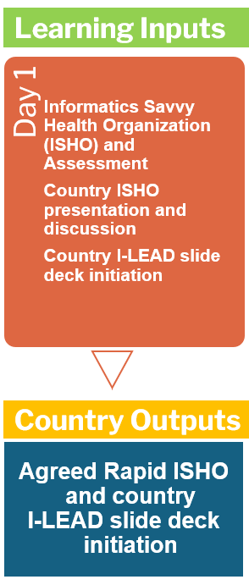

Day 1 Facilitators’ Guide

Session ​ | Duration  (minutes)​ | Facilitator/lead | Facilitation guidance notes | Key facilitation skills | Resources
Welcome and housekeeping​ | 30​ | [Insert name(s)] | - Use warm, inclusive, and respectful language. This is an opportunity to start applying adult learning principles as well as facilitation skills.  - Invite participants to introduce themselves and reflect briefly on their expectations. Record responses on a flipchart and keep them for review on Day 5.  - Share housekeeping and compliance requirements (such as signing daily attendance).  - Allow participants to set house and engagement rules, record them on a flipchart, and pin them on a wall.  - Walk through the Day 1 agenda. | - Use warm, inclusive, and respectful language. This is an opportunity to start applying adult learning principles as well as facilitation skills:  - Adult learning principles:  - Be respectful in language, tone, and time.  - Acknowledge prior experience.  - Acknowledge participants’ expectations and link them to training relevance.  - Facilitation skills: strong communication, cultural awareness and inclusion, effective body language, and voice modulation. | - Day 1 master deck.  - Participant agenda.  - I-LEAD Facilitators’ Guide resource: Section 2–Adult Learning Principles; Section 5–Facilitating Learning.
Welcome remarks | 45​ | [Insert name(s)] | - Introduce the speakers.  - After the remarks, emphasize how the training supports national digital health strategies.  - Summarize 2–3 key points afterward, linking them to training objectives.  - Ensure that the speakers prepare written remarks. | - Facilitation skills: strong communication, cultural awareness and inclusion, effective body language, and voice modulation. | - Day 1 master deck.
I-LEAD roadmap for the week | 10​ | [Insert name(s)] | - Present the roadmap slides, highlighting daily inputs and outputs.  - Review each day’s inputs and outputs.  - Emphasize the final output—a documented, high-level Action Plan—and explain how it builds across the five days. | - Use warm, inclusive, and respectful language. Apply adult learning principles as well as facilitation skills. | - Day 1 master deck.
Safe spaces icebreaker: “Who we are and what we bring” | 20 |  | - Icebreaker prompt (safe spaces): “Which topic are you most eager to explore this week?”  - You will need to have large Post-it notes or pieces of paper and pens for this activity.  - Prepare your papers (participants):  - On one piece of paper, write your job title.  - On a separate piece of paper, write what you feel you bring to the discussion (your skills, perspectives, or experience).  - Seating:  - Sit on the paper with your job title.  - Combine and shuffle:  - Place all other papers (value/skills) in a central pile so they are anonymous.  - Facilitator reads aloud:  - The facilitator randomly selects papers and reads them aloud, highlighting the variety of roles and contributions in the room.  - Debrief (optional):  - Invite participants to reflect briefly on the diversity of perspectives and how everyone’s input is valued. | - Icebreakers warm up the group, reduce tension, and create a comfortable environment. Icebreakers help participants get to know each other and begin engaging. They are used at the start of a session or before transitioning into heavier content. The focus of icebreakers is on people and relationships, not the training content, and they are designed to encourage participation, trust, and engagement.  - A good icebreaker during in-person trainings sets the tone, energizes the group, and creates a foundation for engagement.  - Cultural awareness is crucial, as some icebreakers may work against cultural norms. | - Day 1 master deck.  - I-LEAD Facilitators’ Guide resource: Section 2–Adult Learning Principles; Section 5–Facilitating Learning.
Pre-test ​ | 20 | [Insert name(s)] | - Agree on the role and need for the pre-test.  - Share the link or QR code for the pre-test.  - Assure participants that it is diagnostic, not evaluative.  - Provide guidance on time allocation.  - Plan how to share and use feedback and the report. | Determine the role of the pre-test:  - Diagnose the baseline knowledge or skill level of participants.  - Initiate participants' focus, curiosity, and engagement.  - Help tailor delivery to respond to the pre-test results.  - Manage digital tools for feedback and assessment. | - Day 1 master deck  - Link or QR code to the online pre-test uploaded in advance.  - I-LEAD Facilitators’ Guide resource: Section 2–Adult Learning Principles; Section 5–Facilitating Learning; Section 6–Monitoring Learning.
TEA/COFFEE​ | 20​
Leading and managing an Informatics-Savvy Health Organization (ISHO)​ | 30​ | [Insert name(s)] | - Present the core slides on leading and managing an ISHO, with emphasis on the definition of an ISHO. Use the three-legged table image and description:  - Policy and governance.  - Skilled workforce.  - Effective information systems.  - Country profile: before I-LEAD, replace slides 33–36 with the relevant country’s profile, using the example provided. | - Present content that builds on concepts already known, moving from simple to complex.  - Use multimodal methods (VARK: Visual, Auditory, Reading/Writing, and Kinesthetic).  - Use questions to encourage active participation, promote critical thinking and experience sharing, and check understanding.  - Be aware of your body language and voice modulation, and prepare to manage difficult questions. | - Day 1 master deck.  - I-LEAD Facilitators’ Guide resource: Section 2–Foundations of Adult Learning; Section 3–Types of Learners and Learning Modalities; Section 5–Facilitating Learning.
What is rapid ISHO assessment  ​ | 30​ | [Insert name(s)] | - Facilitate rapid ISHo assessment session. | - Use strong communication, effective body language, and voice modulation.  - Encourage participation, critical thinking, and experience sharing. | - Day 1 master deck.  - ISHO assessment tool.
LUNCH​ | 60​
Country presentation of rapid ISHO assessment | 30 | [Insert name(s)] | - Present rapid ISHO assessment results done pre-I-LEAD | - Use strong communication, effective body language, and voice modulation.  - Encourage participation, critical thinking, and experience sharing. | - Day 1 master deck.  - I-LEAD Facilitators’ Guide resource:
Q&A and discussion about key areas of focus for the week | 60 |  | - Facilitate a Q&A session based on rapid ISHO results and country presentation to identify key areas/problems/ gaps to focus on in the week | - Adaptability and problem-solving, including flexibility, reading the room, adjusting pacing, and responding to needs. | - Day 1 master deck.  - I-LEAD Facilitators’ Guide resource:
Review of country presentation template for the week | 30 |  | - Review of country presentation template that the participants will built on during the week | - Encourage participation, critical thinking, and experience sharing. | - Day 1 master deck.  - I-LEAD Facilitators’ Guide resource:
End-of-day activities |  | [Insert name(s)] | End-of-day evaluation:  - Dedicate time to the end-of-day evaluation.  - Before this, ensure that the evaluation is uploaded to an online tool and that a link or QR code is added to the slide deck.  Day 1 wrap-up:  - Q&A on any of the sessions held today.  - What to expect on Day 2.  - Day 1 reflections:  - What did you expect?  - Did this meet those expectations?  - What can be done differently? | - An evaluation is a systematic process of collecting and analyzing information to determine the effectiveness, efficiency, relevance, and impact of a training program.  - Use the end-of-day evaluation to provide immediate feedback and adjust delivery based on participant responses  - The wrap-up session is a “pause and reflect” activity and provides an opportunity to reflect on the day’s sessions. | - Day 1 master deck.  - Link or QR code to the online end-of-day evaluation uploaded in advance.  - I-LEAD Facilitators’ Guide resource: Section 2–Habit Formation; Section 6–Monitoring Learning.
Group photo, followed by Day 1 reflections and wrap-up ​ | 20​ | [Insert name(s)] | Use this time for a group session. This session may be scheduled earlier or later, possibly before or after other breaks.
Debrief | Open | Implementation team | After the day’s sessions, hold a debrief for the facilitators and the implementation team to review the day, including the end-of-day evaluation, and identify areas that need strengthening or adjustment for the subsequent day to address challenges and gaps. | - A basic flow of “What went well?”, “What didn’t happen?”, and “How do we adjust?”, combined with set facilitator feedback questions, can be a valuable framework when used in conjunction with real-time participant feedback available at the end of each day or session. | - I-LEAD Facilitators’ Guide resource: Section 8–Special Considerations.

Day 2
The Day 2 output comprises prioritized lists of gaps and opportunities for capacity-strengthening across the three workstreams.

Day 2 facilitator checklist
☐ Day 2 slide deck loaded and checked.
☐ Day 1 output: Guided interdepartmental country baseline ISHO assessment available.
☐ Participants are aware of the three workstreams and prepared to join one workstream.
☐ Marshmallow Challenge materials available.
☐ Link or QR code for the end-of-day evaluation added to the Day 2 slide deck.
☐ Debrief meeting with co-facilitators scheduled.

Learning objectives
By the end of Day 2 sessions, participants should be able to:
- Discuss the Four Thinking Hats.
- Prioritize gaps and opportunities for capacity-strengthening across the three workstreams.

Day 2 inputs and outputs
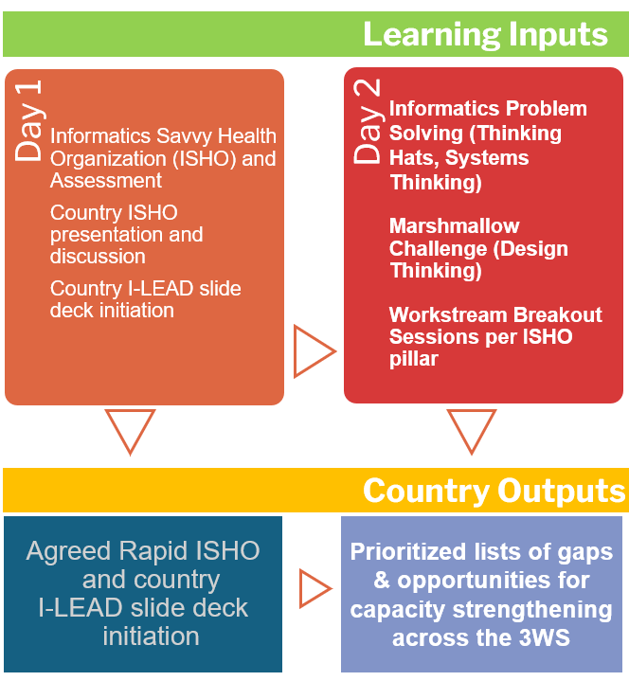

Day 2 Facilitators’ Guide
Session ​ | Duration  (minutes)​ | Facilitator/lead | Facilitation guidance notes | Key facilitation skills | Resources
Welcome and housekeeping | 10 | [Insert name(s)] | - Welcome participants, building on the rapport established on Day 1.  - Invite a participant to lead a debrief of Day 1.  - Emphasize any housekeeping requirements.  - Acknowledge feedback from the end-of-day evaluation and assure participants that the issues raised will be addressed.  - Display the Day 2 agenda, emphasizing inputs and outputs. | - Strong communication, cultural awareness, effective body language, and voice modulation.  - Active listening.  - Time management. | - Day 2 master deck.  - Participant agenda.
Review of the ISHO rapid assessment process and outcomes | 60 | [Insert name(s)] | - This is a great opportunity to link what was done on Day 1 to what will be done on Day 2.  - Facilitate feedback using open-ended questions. Affirm contributions. Link outcomes to real-world relevance. | - Active listening, synthesis, managing group dynamics, and handling difficult questions. | - Day 2 master deck.  - Participant agenda.  - I-LEAD Facilitators’ Guide resource: Section 5–Facilitating Learning.
Informatics problem-solving: Four Thinking Hats | 20 | [Insert name(s)] | - Introduce the Four Thinking Hats using props. Use interactive quizzes. Encourage creative thinking.  - Use the “Six Blind Men and the Elephant” metaphor. Encourage discussion and reflection. | - Creative facilitation, interactive engagement, and gamification strategies.  - Use probing questions and apply skills for handling difficult questions.  - Storytelling.  - Layering information and scaffolding learning. | - Day 2 master deck.  - Participant agenda.  - I-LEAD Facilitators’ Guide resource: Section 2–Adult Learning Principles; Section 5–Facilitating Learning.
Informatics problem-solving: Systems thinking and design thinking | 40 | [Insert name(s)] | - Present concepts visually and with stories. Facilitate group discussion and reflection. | - Present content that builds on concepts already known, moving from simple to complex.  - Use examples to enhance learning.  - Use questions to encourage active participation, promote critical thinking and experience sharing, and check understanding.  - Be aware of your body language and voice modulation, and prepare to manage difficult questions. | - Day 2 master deck.  - Participant agenda.
TEA/COFFEE | 20
Using design thinking for informatics problem-solving activity: Marshmallow Challenge | 40 | [Insert name(s)] | - Provide instructions and organize small groups. Encourage teamwork, creativity, and fun.  - Debrief afterward, linking back to design thinking principles. | - Group facilitation, energizing, managing time and materials.  - Breakout management.  - Time management.  - Managing group dynamics. | - I-LEAD Facilitators’ Guide resource: Section 2–Adult Learning Principles; Section 3–Learner Types and Modalities, Section 5–Facilitating Learning.
LUNCH | 60
Workstream sessions (include a tea/coffee break)  - Information systems and technology.  - Informatics health policy and governance.  - Health informatics workforce. | 120 | [Insert name(s)] | - Organize participants into three groups: Health informatics workforce, informatics health policy and governance, information systems and technology. Guide them to identify and prioritize gaps and opportunities for capacity-strengthening. Encourage documentation of group outputs.  - Workstream 1 Technology  - Workstream 2 Governance  - Workstream 3 Workforce | - Group facilitation, managing breakout rooms, synthesis, and prioritization. | - I-LEAD Facilitators’ Guide resource: Section 2–Adult Learning Principles; Section 5–Facilitating Learning.
Workstream feedback | 30 | [Insert name(s)] | - Each group shares a prioritized list of gaps and opportunities.  - Facilitate synthesis across groups.  - Highlight cross-cutting themes. | - Synthesis, time management, and feedback facilitation.  - Group dynamics.  - Learning reinforcement.  - Habit formation. | - I-LEAD Facilitators’ Guide resource: Section 2–Adult Learning Principles; Section 5–Facilitating Learning.
Day 2 reflections and wrap-up | 20 | [Insert name(s)] | - Share a link or QR code to the online feedback form. Encourage completion. Reassure participants of anonymity and the importance of feedback.  - Facilitate Q&A and reflections. Use recap activities. | - Reflection facilitation, feedback collection, recapping, and action planning. | - Day 2 master deck.  - Link or QR code to the online end-of-day evaluation uploaded earlier.  - I-LEAD Facilitators’ Guide resource: Section 2–Habit Formation; Section 6–Monitoring Learning.
Debrief | Open | Implementation team | - After Day 2 sessions, hold a debrief for the facilitators and the implementation team to review the day, including the end-of-day evaluation, and identify what should be strengthened or adjusted for the subsequent day to address challenges and gaps. | - A basic flow of “What went well?”, “What did not happen?”, and “How do we adjust?”, combined with set facilitator feedback questions, can be a valuable framework when used in conjunction with real-time participant feedback available at the end of each day or session. | - I-LEAD Facilitators’ Guide resource: Section 8–Special Considerations.

Day 3

Day 3 facilitator checklist
☐ Day 3 slides loaded and checked.
☐ Day 2 output: Prioritized list of gaps and opportunities for capacity-strengthening across the three workstreams available.
☐ All materials and instructions for the Draw Toast activity are available.
☐ All materials and instructions for the station rotation exercise are available.
☐ Debrief meeting with co-facilitators scheduled.

Day 3 inputs and outputs
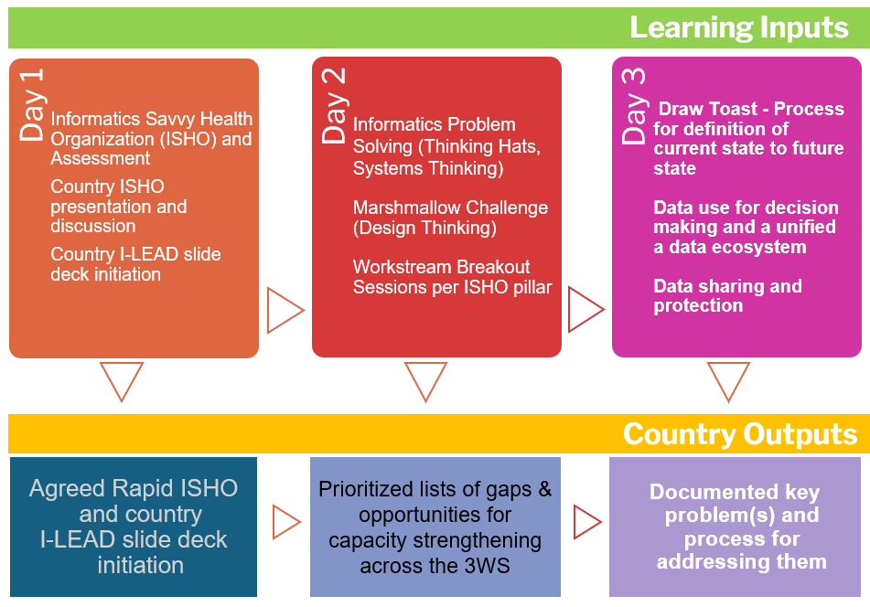

Day 3 Facilitators’ Guide
Session ​ | Duration  (minutes)​ | Facilitator/lead | Facilitation guidance notes | Key facilitation skills | Resources
Welcome and housekeeping | 10 | [Insert name(s)] | - Use warm, inclusive language. Share Wi-Fi details, the agenda, and house rules. Model respect, affirmation, and engagement.  - Invite a participant to lead a recap. | - Strong communication, cultural awareness, effective body language, and voice modulation. | - Day 3 master deck.  - I-LEAD Facilitators’ Guide resource: Section 2–Adult Learning Principles; Section 5–Facilitating Learning.
Draw Toast activity | 30 | [Insert name(s)] | - Facilitate Draw Toast activity. Watch a YouTube video of approximately nine minutes long and allow 20 minutes afterward for the activity.  - Source: http://www.drawtoast.com/  - Provide participants with paper and pens or markers.  - Use systems thinking to visualize the current versus future state. Guide group reflection and strategy planning. | - Visual facilitation, group dynamics, and reflection.  - Use multimodal methods (VARK: Visual, Auditory, Reading/Writing, and Kinesthetic).  - Link theory to practice with real-world examples. | - Day 3 master deck.  - I-LEAD Facilitators’ Guide resource: Section 2–Adult Learning Principles; Section 5–Facilitating Learning.
Current to future state: Strategy development and execution | 45 | [Insert name(s)] | - Facilitate the content on the slide deck.  - Guide group work using Mintzberg’s Four Ps: Plan, Pattern, Position, and Perspective. Facilitate brainstorming and collaborative positioning. | - Strategic thinking, facilitation, synthesis, and collaborative planning. | - Day 3 master deck.  - I-LEAD Facilitators’ Guide resource: Section 2–Adult Learning Principles; Section 5–Facilitating Learning.
TEA/COFFEE | 20
Current to future state: Breakout activity and feedback | 100 | [Insert name(s)] | - Facilitate breakout groups to document key problems and processes for addressing them. Use sticky notes and templates.  - Guide participants to use skills from earlier sessions to produce a document outlining the current state (listing key problems), the future state (what a solution will look like), and a process to move from current to future state. | - Group dynamics and facilitation .  - Strategic thinking, facilitation, synthesis, and collaborative planning. | - Day 3 master deck.  - I-LEAD Facilitators’ Guide resource: Section 2–Adult Larning Principles; Section 5–Facilitating Learning.
LUNCH | 60
Data use for decision-making | 30 | [Insert name(s)] | - Present challenges and solutions for health data use. Facilitate discussion on data access, analysis, and policy integration. | - Apply adult learning principles.  - Scaffold learning from simple to complex.  - Use multimodal methods (VARK).  - Prioritize content (must know/should know/could know).  - Use strong communication, effective body language, and voice modulation.  - Link theory to practice with real-world examples. | - Day 3 master deck.  - I-LEAD Facilitators’ Guide resource: Section 2–Adult Learning Principles; Section 5–Facilitating Learning.
Health information exchange: Supporting a unified data ecosystem for system strengthening | 45 | [Insert name(s)] | - Facilitate the session using the slide deck provided. Use examples and visuals. Facilitate Q&A. | - Present content from simple to complex, building on what participants already know.  - Use multimodal methods (VARK).  - Prioritize content (must know/should know/could know).  - Use questions to encourage active participation, promote critical thinking and experience sharing, and check understanding.  - Be aware of your body language and voice modulation, and prepare to manage difficult questions. | - Day 3 master deck.  - I-LEAD Facilitators’ Guide resource: Section 2–Adult Learning Principles; Section 5–Facilitating Learning.
TEA/COFFEE | 15
National data repositories: Supporting country-owned real-world data (RWD) systems | 60 | [Insert name(s)] | - Facilitate the station rotation exercise. Guide participants through core themes: benefits, challenges, and sustainability.  - Facilitate the formation of three groups. Assign each group a station and provide flipcharts and marker pens.  - Round 1: Each group takes a station and discusses and records on a flip chart.  - Round 2: Swap stations so that each group adds to initial discussions on the flipchart (using different pen colors).  - Round 3: Discussion and reflection: Move all participants from Station 1, then 2, and finally 3, allowing initial groups to present their discussions and permitting additions or questions from the rest. | - Interactive facilitation, station management, and synthesis.  - Apply group dynamics principles. | - Day 3 master deck.  - I-LEAD Facilitators’ Guide resource: Section 2–Adult Learning Principles; Section 5–Facilitating Learning.
Policy, process, and design of data integration and data sharing agreements and data protection | 30 | [Insert name(s)] | - Present concepts of data integration, data sharing agreements, and data protection. Facilitate discussion and reflection. | - Present content building on concepts already known, from simple to complex.  - Use examples to enhance learning.  - Use multimodal methods (VARK).  - Prioritize content (must know/should know/could know).  - Use questions to encourage participation. Be aware of your body language and voice modulation, and prepare to manage difficult questions. | - Day 3 master deck.  - I-LEAD Facilitators’ Guide resource: Section 2–Adult Learning Principles; Section 5–Facilitating Learning.
Day 3 reflections and wrap-up | 20 | [Insert name(s)] | - Share a link or QR code to the online feedback form. Encourage completion. Reassure anonymity and emphasize the importance of feedback.  - Facilitate Q&A and reflections. Use recap activities. | - Reflection facilitation, feedback collection, recapping, and action planning. | - Day 3 master deck.  - Link or QR code to the online end-of-day evaluation uploaded earlier.  - I-LEAD Facilitators’ Guide resource: Section 2–Habit Formation; Section 6–Monitoring Learning.
Debrief | Open | Implementation team | After the day’s sessions, hold a debrief for the facilitators and the implementation team to review the day, including the end-of-day evaluation, and identify areas that need strengthening or adjustment for the subsequent day to address challenges and gaps. | A basic flow of “What went well?”, “What did not happen?”, and “How do we adjust?”, combined with set facilitator feedback questions, can be a valuable framework when used in conjunction with real-time participant feedback available at the end of each day or session. | - I-LEAD Facilitators’ Guide resource: Section 8–Special Considerations.

Day 4

Day 4 facilitator checklist
☐ Day 4 slide deck loaded and checked.
☐ Day 3 output: Documented key problem(s) and processes for addressing them.
☐ All materials and instructions for Bring Your Own Difficult Decision (BYODD) available.
☐ All materials and instructions for Value Claims for Health Information Systems (HIS) available.
☐ Debrief meeting with co-facilitators scheduled.

Day 4 inputs and outputs
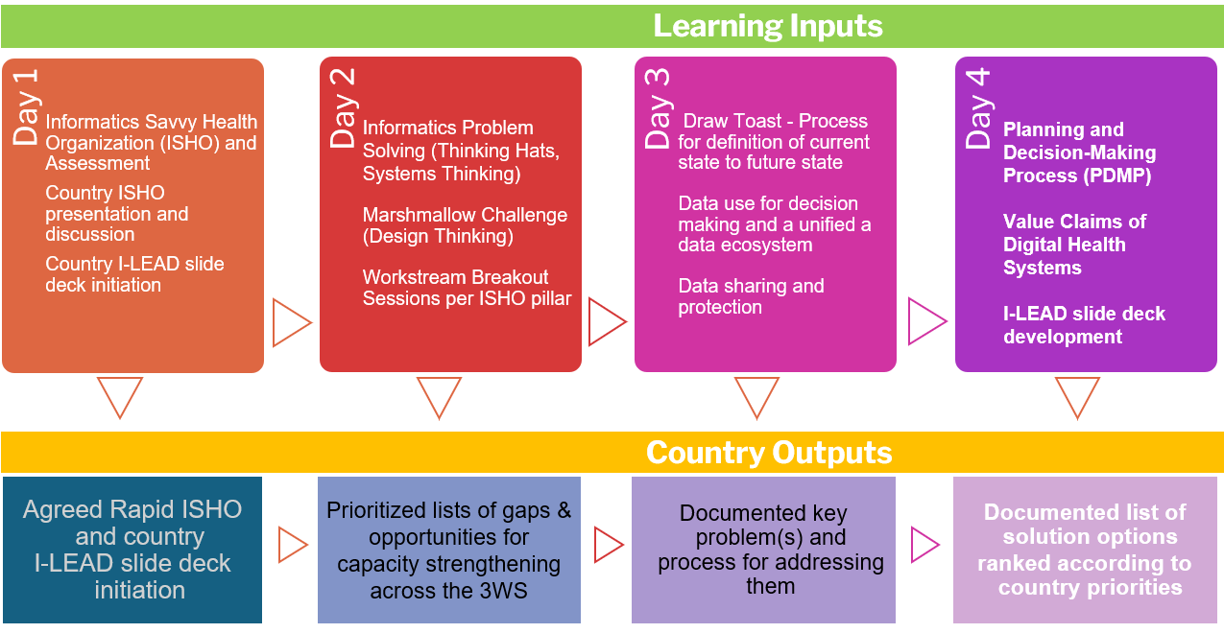

Day 4 Facilitators’ Guide
Session ​ | Duration  (minutes)​ | Facilitator/lead | Facilitation guidance notes | Key facilitation skills | Resources
Welcome and housekeeping | 10 | [Insert name(s)] | - Use warm, inclusive language. Share Wi-Fi details, the agenda, and house rules. Model respect, affirmation, and engagement. | - Strong communication, cultural awareness, effective body language, and voice modulation. | - Day 4 master deck.
[Add relevant content}  Global goods for Health Information Systems (HIS) sustainability  OR  Biometrics and Unique Identifiers (UIDs)  OR  Artificial intelligence: Care beyond boundaries | 45 | [Insert name(s)] | - Present build, buy, and adapt options and the entire content in this session. Facilitate discussion on open-source versus proprietary approaches. Use myths and a guidebook as supporting materials.  - Present content on slide deck  - Present the “Artificial intelligence: Care beyond boundaries” content. Use questioning or brainstorming techniques to discuss opportunities and ethical pitfalls. | - Present content from simple to complex, building on what participants already know.  - Link theory to practice with real-world scenarios and participant-generated examples.  - Adjust technical content for diverse audiences (executives, technical specialists, non-technical staff, end users).  - Prioritize content (must know/should know/could know). | - Day 4 master deck.  - I-LEAD Facilitators’ Guide resource:
Planning and decision-making process | 45 | [Insert name(s)] | - Guide participants through structured decision-making steps. Use a decision-making matrix and relevant examples. Facilitate group analysis. | - Link theory (training content) to practice (real-world application) by providing examples and encouraging participants to generate their own through probing questions or guided brainstorming.  - Prioritize content (must know/should know/could know).  - Be aware of your body language and voice modulation, and prepare to manage difficult questions.  - Use visual aids, diagrams, flowcharts, and infographics. | - Day 4 master deck.  - I-LEAD Facilitators’ Guide resource:
COFFEE/TEA | 20
Activity: Bring Your Own Difficult Decision (BYODD) | 120 | [Insert name(s)] | - The output of the "Bring Your Own Difficult Decision" activity builds on the current-to-future state plan developed on Day 3. The aim is to guide participants to brainstorm possible solutions and produce a list of options ranked by country priorities. Participants should use the decision-making matrix for this process. This output will serve as an input into the final activity on Day 5 to produce an action plan.  - The "Bring Your Own Difficult Decision" activity invites participants to bring real-life challenges they are facing and collaboratively brainstorm solutions. This format encourages collaboration, perspective-taking, and the application of decision-making frameworks to tangible problems.  Pre-activity: Participants identify and briefly describe a difficult decision they are currently facing. They should be prepared to share the context, potential options, and any constraints they are aware of.  Activity structure:  - Introduction: The facilitator explains the activity's purpose and process.  - Decision sharing: Participants take turns briefly presenting their difficult decisions, focusing on clear and concise explanations rather than lengthy narratives.  - Brainstorming: For each decision, the group engages in brainstorming. Participants offer diverse perspectives, potential solutions, and considerations the decision-maker may not have considered. This may involve various decision-making models or open idea generation. Use the decision-making matrix provided.  - Action planning: After brainstorming, the group helps the decision-maker outline actionable steps they can take to move forward.  - Reflection: At the end of the activity, participants reflect on what they learned from the process, both about the specific decision and about their own decision-making style. | - Group dynamics and facilitation skills.  - Adaptability and problem-solving, including flexibility, reading the room, adjusting pacing, and responding to needs.  - Prioritize content (must know/should know/could know). | - Day 4 master deck.  - I-LEAD Facilitators’ Guide resource:
LUNCH | 60
Value claims for Health Information Systems (HIS) | 60 | [Insert name(s)] | - Present value claims across the HIS lifecycle. Facilitate a group activity to identify project value claims.  Group activity:  - Choose one priority strategy or problem.  - Identify one or two projects to address that strategy or problem.  For each project:  - Describe what the project will accomplish at a high level, including the work that will be done.  - Identify value claims for the informatics project in line with its stage of maturity.  - Identify stakeholders who would be interested in these value claims.  - You can use the Information Value Cycle to develop value claims.  - Conduct monitoring and evaluation.  - Identify what types of data need to be collected to support value claims.  - Identify what types of analysis (quantitative, qualitative, or mixed) are needed based on the collected data to arrive at answers. | - Group dynamics and facilitation skills.  - Adaptability and problem-solving, including flexibility, reading the room, adjusting pacing, and responding to needs.  - Prioritize content (must know/should know/could know). | - Day 4 master deck.  - I-LEAD Facilitators’ Guide resource:
Activity: Work on country presentation template | 60 | [Insert name(s)] | - Facilitate session to allow participants work on country presentation | - Adaptability and problem-solving, including flexibility, reading the room, adjusting pacing, and responding to needs. | - Day 4 master deck.  - Presentation template
End-of-day evaluation and wrap-up | 20 | [Insert name(s)] | - Share a link or QR code to the evaluation. Facilitate reflections and preview Day 5. Use recap techniques. | - Feedback collection, reflection facilitation, and recap. | - Day 4 master deck.
Debrief | Open | Implementation team | - After the day’s sessions, hold a debrief for the facilitators and the implementation team to review the day, including the end-of-day evaluation, and identify what needs to be strengthened or adjusted for the subsequent day to address challenges and gaps. | - A basic flow of “What went well?”, “What did not happen?”, and “How do we adjust?”, combined with set facilitator feedback questions, can be a valuable framework when used in conjunction with real-time participant feedback available at the end of each day or session. | - I-LEAD Facilitators’ Guide resource: Section 8–Special Considerations.

Day 5

Day 5 facilitator checklist
☐ Day 5 slide deck loaded and checked.
☐ Day 4 output: Documented list of solution options ranked by country priorities.
☐ Regional representative is aware of the Communities of Practice (CoPs) session and has confirmed availability.
☐ Debrief meeting with co-facilitators scheduled.
By the end of today’s sessions, participants should be able to:
- Use knowledge and skills developed during the week to develop a high-level action plan to move from the current state to the desired future state.
- Describe the regional groups and CoPs that can be leveraged for future engagement.

Day 5 inputs and outputs
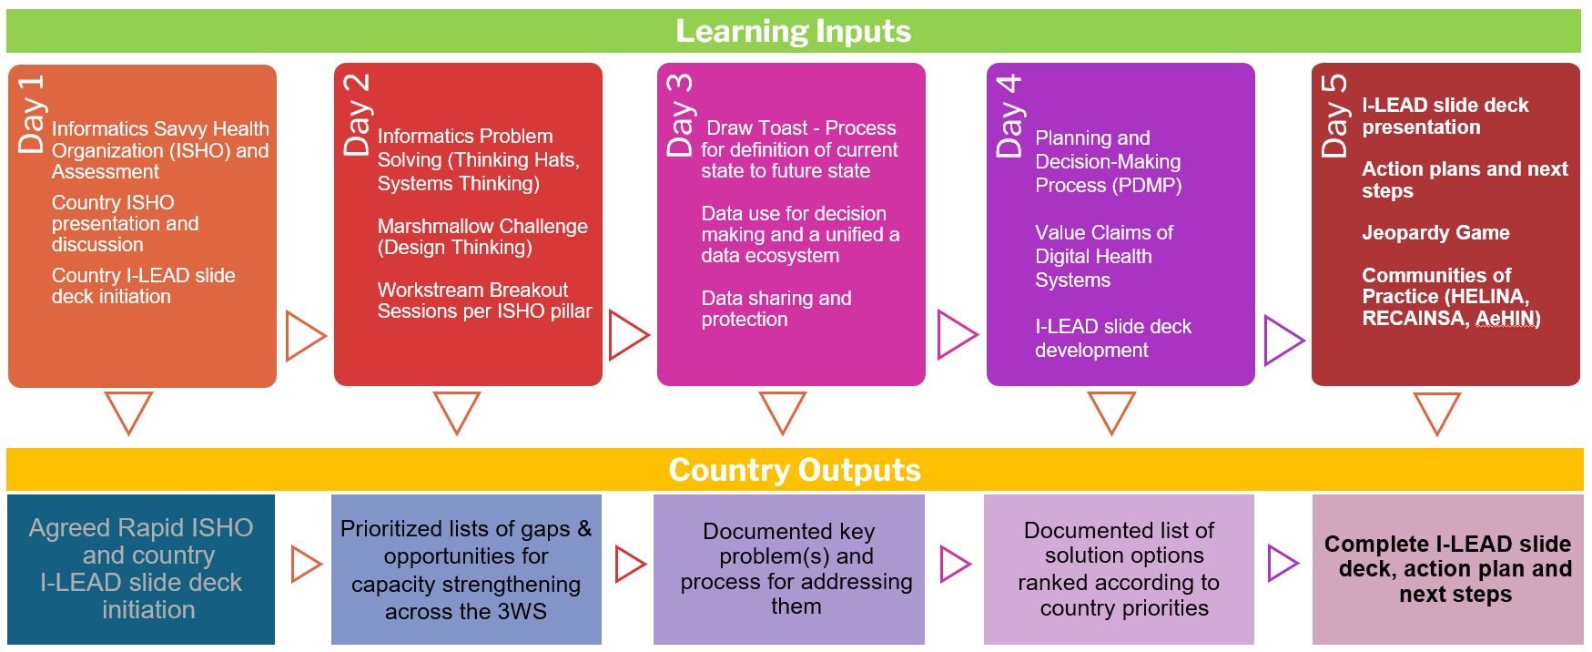

Day 5 Facilitators’ Guide
Session ​ | Duration  (minutes)​ | Facilitator/lead | Facilitation guidance notes | Key facilitation skills | Resources
Welcome and housekeeping | 10 | [Insert name(s)] | - Use warm, inclusive language. Share Wi-Fi details, the agenda, and house rules. Model respect, affirmation, and engagement. | - Strong communication, cultural awareness, effective body language, and voice modulation. | - Day 5 master deck.
Country I-LEAD slide deck presentation | 30 | [Insert name(s)] | - Facilitate country presentation and discussions. | - Problem-solving, strategic facilitation, and synthesis. | - Day 5 master deck.
Activity: Developing the action plan | 60 | [Insert name(s)] | - Facilitate breakout sessions.  - Guide participants to build high-level action plans using Informatics-Savvy Health Organization (ISHO) pillars. Encourage collaboration and use of outputs from previous days. | - Group dynamics and facilitation skills.  - Adaptability and problem-solving, including flexibility and reading the room. | - Day 5 master deck.  - I-LEAD Facilitators’ Guide resource:
Feedback and reflections on the action plan | 30 | [Insert name(s)] | - Facilitate group presentations and reflections. | - Use teach-back methods and peer review. | - Day 5 master deck.
COFFEE/TEA | 15
Post-test | 30 | [Insert name(s)] | - Guide participants through the post-test. Ensure clarity and provide support. | - Monitoring learning through the post-test.  - Determine the role of the post-test, largely informed by the pre-test  - Assess knowledge, skills, or attitudes acquired compared to the baseline established by the pre-test.  - Provide evidence of whether the learning objectives were met.  - Reinforce key concepts through recall and application to strengthen retention.  - Where applicable, use the post-test as a formal requirement for completion or competency validation. | - Day 5 master deck.  - I-LEAD Facilitators’ Guide resource:
Jeopardy game | 30 | [Insert name(s)] | Instructions to facilitators:  - Open the link to the Jeopardy game: https://jeopardylabs.com/edit2/144326352  - Enter the password: I-LEAD.  - Review the questions and update as necessary.  - Click “Save and Finish.”  - Facilitate an interactive recap using the Jeopardy format.  - Encourage team play and knowledge reinforcement. | - Monitor learning through real-time feedback tools such as the Jeopardy activity.  - Gamification.  - Make learning fun | - Day 5 master deck.  - I-LEAD Facilitators’ Guide resource:
Final evaluation and catering feedback | 20 | [Insert name(s)] | - Guide participants through the final evaluation. Encourage honest feedback. | - Remember that the role of evaluation is to guide future improvements by collecting and analyzing information to determine the effectiveness, efficiency, relevance, and impact of the training program.  - Analyze and document feedback, and incorporate it into the post-I-LEAD debrief. | - Day 5 master deck.
Leveraging peer connections for post-I-LEAD engagement | 30 | [Insert name(s)] | - Invite a representative from the regional Community of Practice (CoP)—such as AeHIN, HELINA, RECAINSA, or Shiriki—to present on the CoP. If no representative is available, prepare content to present yourself. Facilitate discussion on future engagement. | - Strong communication, cultural awareness, effective body language, and voice modulation. | - Day 5 master deck.  - I-LEAD Facilitators’ Guide resource: Section 7 – post training support
Award of certificates and closing remarks | 15 | [Insert name(s)] | - Celebrate achievements. Share closing reflections and outline next steps. | - Strong communication, cultural awareness, effective body language, and voice modulation. | - Day 5 master deck.
Debrief | Open | Implementation team | - After the day’s sessions, hold a debrief with the facilitators and the implementation team to review the day, including the end-of-day evaluation, and identify what needs to be strengthened or adjusted for future workshops to address challenges and gaps. | A basic flow of “What went well?”, “What did not happen?”, and “How do we adjust?”, combined with set facilitator feedback questions, can be a valuable framework when used in conjunction with real-time participant feedback available at the end of each day or session. | - I-LEAD Facilitators’ Guide resource: Section 8–Special Considerations.

Day 2 Workstream 1 – Technology
Session ​ | Duration  (minutes)​ | Facilitator/lead | Facilitation guidance notes | Key facilitation skills | Resources
Introduction and objectives | 30 | [Insert name(s)] | Set context by introducing Informatics-Savvy Health Organization (ISHO) pillars, Open Health Information Exchange (OpenHIE), and Health Information Exchange (HIE) implementations. Clarify session goals and group roles such as note-taker and spokesperson. | - Clear communication, context setting, and group management. | - Workstream 1 slide deck.
Group discussion: HIE and interoperability | 30 | [Insert name(s)] | Facilitate a discussion on HIE, registry services, and the interoperability layer. Use scenarios and diagrams. Encourage participants to share country experiences. | - Active listening, scenario facilitation, and visual aids. | - Workstream 1 slide deck.  - I-LEAD Facilitators’ Guide resource
Group activity: Component systems and challenges | 60 | [Insert name(s)] | Guide teams to list component systems, their benefits, and challenges. Prioritize 1–2 challenges and develop a strategy or roadmap. Use poster templates. | - Problem-solving, strategic facilitation, and synthesis. | - Workstream 1 slide deck.
Plenary feedback preparation | 10 | [Insert name(s)] | Assign a spokesperson and a note-taker. Structure feedback around 2–3 themes, challenges, and recommendations. Keep the feedback concise. | - Feedback facilitation and time management. | - Workstream 1 slide deck.

Day 2 Workstream 2 – Governance
Session ​ | Duration  (minutes)​ | Facilitator/lead | Facilitation guidance notes | Key facilitation skills | Resources
Introduction and objectives | 10 | [Insert name(s)] | Set context by introducing Informatics-Savvy Health Organization (ISHO) pillars, the governance process, and stakeholder mapping. Clarify session goals and group roles. | - Clear communication, context setting, and group management. | - Workstream 2 slide deck.
Group discussion: Governance, data, and cybersecurity | 30 | [Insert name(s)] | Facilitate a discussion on governance frameworks, data governance, and cybersecurity. Use diagrams and real-world examples. | - Scenario facilitation, policy awareness, and visual aids. | - Workstream 2 slide deck.
Group activity: Challenges and roadmap | 60 | [Insert name(s)] | Guide teams to identify challenges, analyze strategies, and draft a roadmap for 1–2 priority areas. Prepare for plenary feedback. | - Problem-solving, strategic facilitation, and synthesis. | - Workstream 2 slide deck.
Plenary feedback preparation | 10 | [Insert name(s)] | Assign a spokesperson and a note-taker. Structure the feedback around 2–3 themes, challenges, and recommendations. Keep the feedback concise. | - Feedback facilitation and time management. | - Workstream 2 slide deck.

Day 2 Workstream 3 – Workforce
Session ​ | Duration  (minutes)​ | Facilitator/lead | Facilitation guidance notes | Key facilitation skills | Resources
Introduction and objectives | 10 | [Insert name(s)] | Set context by introducing Informatics-Savvy Health Organization (ISHO) pillars, the capacity and capability cycle, and the Vision, Strategy, Operations, and Tactics (VSOT) model. Clarify session goals and assign group roles. | - Clear communication, context setting, and group management. | - Workstream 3 slide deck.
Group activity: Station rotation | 60 | [Insert name(s)] | Facilitate station rotation on workforce development (WFD) strategies, challenges, sustainability, and measuring value. Use prompts and visuals. | - Interactive facilitation, station management, and synthesis. | - Workstream 3 slide deck.  - I-LEAD Facilitators’ Guide resource:
Group discussion and reflection | 30 | [Insert name(s)] | Guide a review round, the newspaper headline exercise, and reflection. Summarize key points for the plenary session. | - Reflection facilitation, creative engagement, and synthesis. | - Workstream 3 slide deck.
Plenary feedback preparation | 10 | [Insert name(s)] | Assign a spokesperson and a note-taker. Structure the feedback around 2–3 themes, challenges, and recommendations. Keep the feedback concise. | - Feedback facilitation and time management. | - Workstream 3 slide deck.

