
Malaria
Malaria solutions—developed in partnership, informed by experience

We envision a world where country leaders and partners have the tools, evidence, financial capacity, human resources, and political will to control, eliminate, and eventually eradicate malaria.

We offer equitable partnerships and deep technical expertise to support national malaria programs in applying existing tools and approaches for maximum impact and cost-effectiveness, while also driving forward development, optimization, and evaluation of promising new tools and approaches essential to maintaining gains and further progress towards elimination.
Technical Support to Ministries of Health
We offer technical and operational support to formulate evidence-based strategies, develop efficient operational plans, deliver interventions, and monitor progress through robust surveillance. These efforts strengthen capacity at national and sub-national levels, increase intervention coverage and effectiveness, and strengthen surveillance.
Since 2005, PATH's Malaria Control and Elimination Partnership in Africa (MACEPA) project funded by the Gates Foundation has supported national strategic and operational planning in 10 countries to strengthen and optimize use of resources. For example, MACEPA supported the development of a national program model in Zambia to identify and implement a package of malaria control interventions, such as quality case management, rapid reporting and surveillance, and vector control. Because of its success, this approach was adopted by the broader RBM Partnership.
In Senegal and The Gambia, MACEPA’s work with the national malaria program has included policy and strategy development to increase collaborative cross-border approaches to malaria surveillance and intervention.

Benin, Burkina Faso, CAR, ​DRC, Ethiopia, ​The Gambia, Ghana, Kenya, Liberia, Madagascar, Malawi, Mali, Mozambique, Nigeria, Senegal, Sierra Leone, Togo, Uganda, Zambia
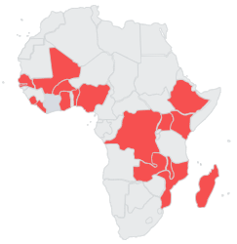
Where We Work

Cambodia, ​
India, Indonesia, Japan, Lao PDR, Myanmar, Papua New Guinea,​ South Korea,
Thailand, Vietnam​


Across MACEPA countries, PATH is applying mathematical modeling to guide program strategy and intervention targeting through the expansion of available data and provision of impact and cost-effectiveness models for various intervention packages at national and sub-national levels. PATH provides direct assistance to national programs and training through workshops and a Data Fellows program to strengthen analytical skills among malaria program leaders.
PATH provides technical assistance for the planning, introduction, and scale up of the malaria vaccine in Burkina Faso, the Democratic Republic of the Congo (DRC), Ethiopia, Ghana, Guinea, Mozambique, Nigeria, and Uganda. Through multiple projects funded by Gavi, the Vaccine Alliance and GiveWell, PATH is supporting the introduction of the malaria vaccine and engaging in a range of activities to ensure robust introduction and uptake, with particular emphasis on ensuring that children receive all four doses. For example, PATH is supporting countries to integrate vaccine data into existing data collection tools for the Essential Programme on Immunization (EPI), strengthen national and provincial coordination structures in order to effectively conduct malaria vaccination campaigns at scale, invest in community engagement and demand generation, and implement monitoring and learning to improve service delivery.
PATH works in the DRC—and previously in Vietnam, The Gambia, and Senegal—with the Ministry of Health to improve their pandemic preparedness by enhancing surveillance data and use by integrating data and developing data visualization dashboards used by national emergency operations centers (EOCs) and national malaria programs. EOCs help countries with their responses to pandemics and infectious diseases such as malaria.
Through the Community Health Care Digitization in Zambia project, PATH is working with the Ministry of Health to develop a community health digitalization platform for consolidating and supporting community health worker activities, training, and reporting to improve service delivery. The investment will pilot, refine, and evaluate the system as well as develop a scale-up implementation plan and sustainability plan.

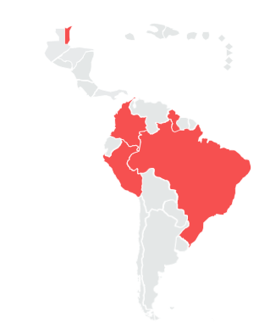

Belize, ​
Brazil, Colombia, Guyana,​
Peru

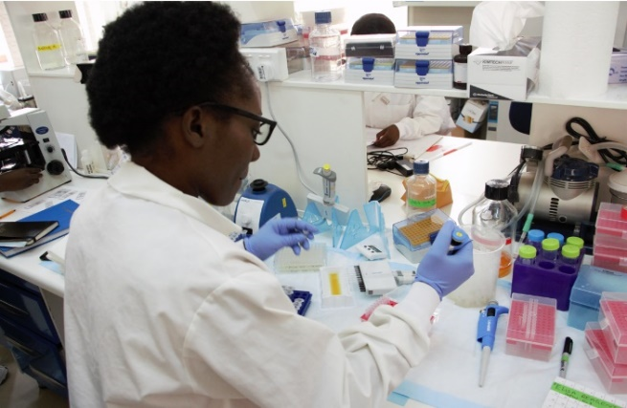

Conceptor Mulube, Laboratory Technologist, conducting an experiment in the National Malaria Elimination Centre lab in Zambia.
Photo: PATH/Hunter Lengel Isgrig

Malaria Prevention and Control Interventions
Through the Rotary Healthy Communities Challenge (RHCC) project in Nigeria, in partnership with The Rotary Foundation and funded by the Gates Foundation, PATH supports the National Primary Health Care Development Agency’s model of training and supervision of community health workers delivering integrated community case management (iCCM), a proven global strategy that focuses on the biggest killers of children in communities—malaria, diarrhea, and pneumonia. The RHCC project is also active in DRC, Mozambique, and Zambia where PATH is a technical assistance partner developing and strengthening health reporting and data systems for at community level.
PATH leads the US President’s Malaria Initiative (PMI) Reaching Every At-Risk Community and Household with Malaria Services (PMI REACH Malaria). This initiative strengthens the planning, delivery, quality, and monitoring of malaria case management services and other life-saving malaria prevention and control interventions, from a national to community level, with a focus on reaching the unreached. PMI REACH Malaria works in Africa and Asia with a focus on regions and countries with a high burden of malaria.
New Tools: Development, Optimization, and Evaluation
PATH is a trusted partner for industry, program leaders, and policy makers in the development, optimization, and evaluation of new tools and approaches for malaria control and elimination from vaccines to diagnostics to chemoprevention.
Malaria vaccines
For more than 3 decades, PATH has been a critical partner in the development and evaluation of the world’s first malaria vaccine, RTS,S/AS01. This included partnerships to implement clinical trials and large-pilot evaluations and informing Gavi and the World Health Organization guidance for countries. PATH is also a partner in assessing impact of R21/Matrix M when co-administered with certain pediatric vaccines, and assessing the impact of integrating delivery of perennial malaria chemoprevention (PMC) with the RTS,S/AS01 vaccine schedule.
Malaria diagnostics
PATH is a key collaborator in the development of more sensitive malaria rapid diagnostic tests for all species of malaria, including P. falciparum with hrp2/3 deletions and P. vivax, and point-of-care tests for glucose-6-phosphate dehydrogenase (G6PD) deficiency to guide treatment of P. vivax. With support from the Gates Foundation and the Australian Government, PATH provides end-to-end support for product development and introduction, including laboratory-based research and development, clinical evaluation, operational research, impact assessment, and market shaping.
To catalyze safer and sustainable access to G6PD diagnostics and drugs for P. vivax, PATH co-leads the Partnership for Vivax Elimination with Medicines for Malaria Venture, funded by Unitaid. This project leverages PATH's product development and market shaping expertise to partner with national malaria programs across three continents to accelerate the adoption of new case management tools.
To increase the resilience of the antimalarial market, PATH is mapping and monitoring supply chains from the agricultural origins of key pharmaceutical precursors to current drug demand and future scenarios for innovative new treatments. We also facilitate the uptake of new synthetic pharmaceutical ingredients to diversify supply chains and mitigate the impacts of climate change on antimalarials.
New malaria control tools
The NOMADS project, funded by the Gates Foundation, has developed a cost–effective, scalable assay to detect antimalarial drug resistance in P. falciparum using nanopore sequencing. Under NOMADS 2, PATH is integrating nanopore sequencing into routine surveillance in Zambia, expanding nanopore sequencing to new geographies, and optimizing nanopore sequencing assays for malaria molecular surveillance.
PATH is a leader in generating observational evidence to evaluate introduction and scale-up of new vector control tools, including next generation insecticide treated nets (ITN) and insecticides for indoor residual spray (IRS). PATH has worked with national programs in more than 10 countries to generate observational evidence of ITN and IRS impact.
PATH was a key partner in the phase III trials of the attractive targeted sugar bait (ATSB). Our Zambia team conducted a two-year cluster randomized controlled trial producing evidence to inform policy and product development.
PATH also recently concluded the pilot introduction of PMC in DRC with funding from GiveWell. PATH supported the Expanded Programme on Immunization and the national malaria program to co-design a DRC-adapted program model; adapt data collection and supervision tools; register and import a pediatric dispersible formulation of sulfadoxine-pyrimethamine (SP); develop community engagement activities; and use PMC data for decision-making.

